ECE 49595

EE SENIOR DESIGN PROJECT

Fall 2016

**SYSTEM MANUAL**

Transparent USB Audio Headphone Amplifier

by

Team Fantastic Four

Section [06] Team Number [2]

|  |  |  |
| --- | --- | --- |
| **Contact:** | Ojal Khandelwal | okhandel@purdue.edu |
|  | Hyunbae Chang | chang132@purdue.edu |
|  | Guanghua Zha | gzha@purdue.edu |
|  | Nathan Rivas | nrivas@purdue.edu |

# Table of Contents

|  |  |
| --- | --- |
| [1. Introduction and System Specification](#_gjdgxs)  [1.1 Whole System Specifications/ Constraints](#_30j0zll)  [2. System Design](#_1fob9te)  [3. Subsystem Design](#_8ptnfqphs8xz)  [3.1 Digital to Analog Subsystem (D to A) + Reconstruction Filter](#_tyjcwt)  [3.1.1 Subsystem Requirement](#_djseuzrqsrh3)  [3.1.2 System Block Diagram & Requirement](#_ic0cdye5pjox)  [3.1.3 Design Process](#_ca7avjso81he)  [3.1.4 Simulation Result](#_b6x6re6zip3c)  [3.1.5 Testing Plan](#_7mpmy0i333ot)  [3.1.6 Circuit Image](#_2yflsx7tg6r5)  [3.2 VU + GUI Controls](#_3dy6vkm)  [3.2.1 Subsystem Requirement](#_e126yxyktr0h)  [3.2.2 Subsystem Block Diagram](#_lpwtf51xw781)  [3.2.3 Schematics and Flow chart](#_uubokzdh2xzf)  [3.2.4. Testing Plan](#_ncxwxum416ue)  [3.2.5 Prototype Photos](#_7orm2x46yznb)  [3.3 Amplifier Controls](#_1t3h5sf)  [3.3.1 Subsystem Requirement](#_a0k3twi36rwe)  [3.3.2 Subsystem Block Diagram](#_n9p8qwfw99kr)  [3.3.3 Design/Schematic](#_919xnvamdict)  [3.3.4 Pspice Simulation Results](#_109yueoqio8y)  [3.3.5 BreadBoard circuit Prototype](#_6whlib1yz5ze)  [3.3.6 Results (Breadboard)](#_84wosr39ztz5)  [3.3.7 PCB Schematic: Altium](#_ymlos9ci2kba)  [3.3.8 PCB Layout](#_ybbcjj7mlmvq)  [3.3.9 Results (PCB)](#_ngwkvxw4u3ne)  [3.3.10 Testing Plan](#_52r7emtk4bak)  [3.4 Power Amplifier](#_4d34og8)  [3.4.1 Subsystem Requirements](#_2s8eyo1)  [3.4.2 Electrical / Audio Specifications, all from 20Hz to 20kHz with 16-600Ω load:](#_krlfuwwcsf3s)  [3.4.3 Power Calculations](#_oqpepnpyl1v3)  [3.4.4 Subsystem Block Diagram](#_2uuj6w7l8rrd)  [3.4.5 Design/ Schematic](#_17dp8vu)  [3.4.6 PSPICE Simulation Results](#_3rdcrjn)  [3.4.7 Prototype](#_56b8k4hwwjr4)  [3.4.8 Oscilloscope Results](#_g20tt9lz5vle)  [3.4.9 PCB Schematic: Altium Designer](#_z925tvd7d4ye)  [3.4.10 PCB Layout](#_q1vpmwnd91gu)  [3.4.11 Testing Plan](#_l1nevo4d3vsx)  [4 Integration of Sub-Systems](#_91527g51n6yp)  [4.1 Digital to Analog Converter with Amplifier Controls](#_o3a06gvxz4j5)  [4.2 VU/GUI with Amplifier Controls](#_axoorig0j4xa)  [4.3 Power Amplifier with Amplifier Controls](#_ucgbng6dotzp)  [4.4 Integration of all Sub-Systems](#_wrybjsbvydca)  [5 Final Acceptance Test](#_8w59efklfxik)  [6 Schedule Of Deliverables](#_44sinio)  [7 Known Costs](#_2jxsxqh)  [Appendix A. Specification Sheets](#_z337ya) | **page……………………………………...4**  **page……………………………………...4**  **page……………………………………...5**  **page……………………………………...6**  **page……………………………………...6**  **page……………………………………...6**  **page……………………………………...6**  **page……………………………………...7**  **page……………………………………...8**  **page……………………………………...10**  **page……………………………………...11**  **page……………………………………...12**  **page……………………………………...12**  **page……………………………………...13**  **page……………………………………...14**  **page……………………………………...19**  **page……………………………………...20**  **page……………………………………...21**  **page……………………………………...21**  **page……………………………………...21**  **page……………………………………...23**  **page……………………………………...23**  **page……………………………………...26**  **page……………………………………...26**  **page……………………………………...27**  **page……………………………………...29**  **page……………………………………...30**  **page……………………………………...31**  **page……………………………………...33**  **page……………………………………...33**  **page……………………………………...33**  **page……………………………………...33**  **page……………………………………...34**  **page……………………………………...34**  **page……………………………………...35**  **page………………………………………39**  **page………………………………………40**  **page………………………………………43**  **page………………………………………43**  **page………………………………………44**  **page………………………………………47**  **page………………………………………47**  **page………………………………………48**  **page………………………………………50**  **page………………………………………51**  **page………………………………………53**  **page………………………………………53**  **page………………………………………54**  **page………………………………………55** |

# 1. Introduction and System Specification

The system is a prototype of an acoustically transparent, integrated audio system that would amplify signals provided by means of USB digital audio (16 bit 44.1 Hz) to a wide variety of headphones. The system is intended for battery operation so power consumption must be minimized throughout the system.

## 1.1 Whole System Specifications/ Constraints

1. All subsystems, unless specified, to be built from basic op-amps (LF356, LM358, etc.), programmable logic devices (PLD 16V8 or 22V10), timers (LM555, 74HC123, etc.),74HCxx and CD4xxx series logic and other support chips.

2. All subsystems should be capable of being demonstrated and powered separately.

3. Electrical / Audio Specifications, all from 20Hz to 20kHz with 16-600Ω load:

1. Support headphone impedances 16Ω - 600Ω.
2. Output impedance < 2Ω.
3. Flat frequency response (±2.5dB).
4. Linear/flat phase response without the reconstruction filter and tone controls set to zero dB (±2°).
5. Noise under -105dBv (-103dBu).
6. Distortion < 1% THD into 150Ω at 1Vrms.
7. Power amplifier must have as slew of >3V/µs using a 10kHz square wave near full output at 600Ω.
8. Must not produce a DC offset >20mV during operation.
9. Must not produce excessive power on/off spikes >50mV.

4. Capable of driving the following headphones at 110dB SPL (note that the manufacturer supplied specifications are confused and poorly specified but do allow a certain level of analysis):

1. Sennheiser HD600 - Sound pressure level 97 dB (SPL) at 1 mW, 300Ω.
2. Koss KSC75 – 101dB (SPL)/mW, 60Ω.
3. Sony MDR-AS200 – 104 dB (SPL)/mW, 16Ω.
4. Beyerdynamic DT-880 - Sound pressure level (SPL) 96 dB at 1mW, 600Ω.
5. Sennheiser HD650 - Sound pressure level (SPL) 103 dB (1 Vrms), 300Ω.
6. Ultimate Ears TripleFi 10 - Sensitivity: 117 dB SPL/mW, 1 kHz, 32Ω.
7. HiFiMAN HE-5LE - Sensitivity: 87.5 dB, 1 mW, 38Ω.
8. Ultrasone Edition 10 – Sound Pressure Level 99 dB, 32Ω.

# 2. System Design

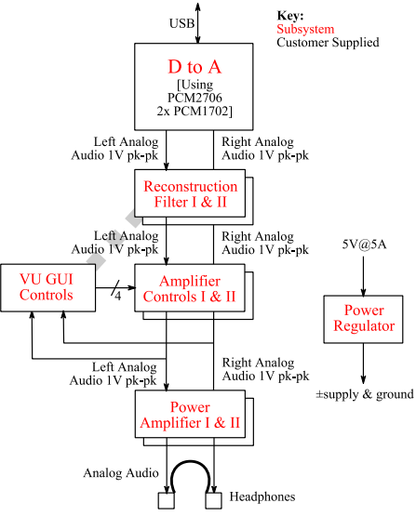

Figure 2.1: System Design Block Diagram

# 3. Subsystem Design

## 3.1 Digital to Analog Subsystem (D to A) + Reconstruction Filter

### 3.1.1 Subsystem Requirement

1. Able to read the data input from the USB interface, transfer the data to I2S bus.
2. Separate the serial in data to left and right channel data, padding the data to 20 bits and generate correct latch enable signal.
3. Use FPGA to generate the clock that require by PCM 1702 for 4x oversampling.
4. Use FPGA to oversample the data.
5. Reconstruct the audio signal with PCM 1702 and convert the current output from PCM 1702 to 1 voltage peak to peak voltage.
6. Filter the voltage output to eliminate high frequency noise.
7. Output 1 V peak to peak voltage signal to next stage.

### 3.1.2 System Block Diagram & Requirement

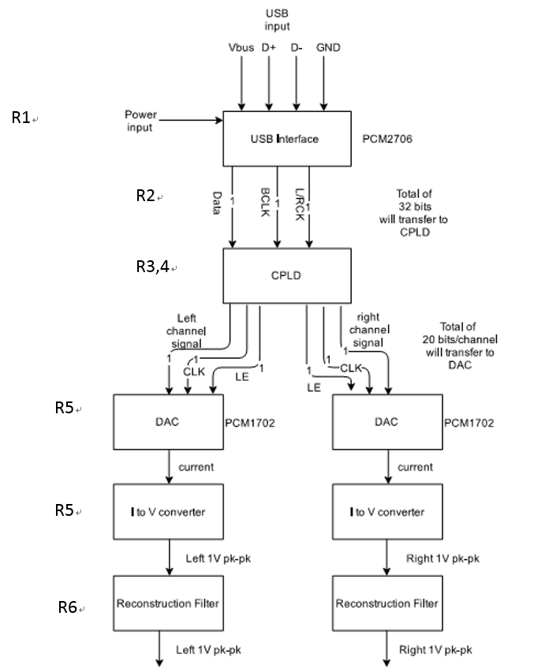

Figure 3.1.2.1 D to A Block Diagram and Requirement

### 3.1.3 Design Process

**Verilog Digital Audio Signal Processing Design (R2&R3&R4)**

After the data was read from the USB and transfer to the I2S bus, the next stage is using FPGA to proceed the data. In the figure below it describe how the FPGA function and how the data is transferred between different block. FPGA also used to generate the clock that need for 4X oversample and also the clock for PCM1702. The output of the FPGA should be the separated left and right channel data, latch enable and a new the clock signal.

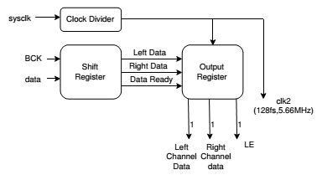

**Figure** below describe the state machine of the two different block in my FPGA.

Shift Register State Machine Output Register State Machine

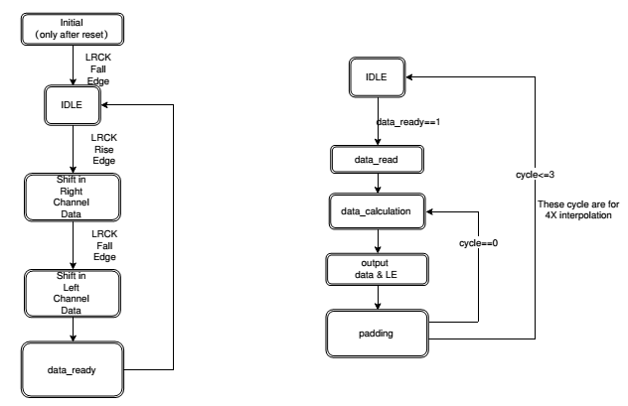

Figure 3.1.3.2 Verilog Design

### 3.1.4 Simulation Result

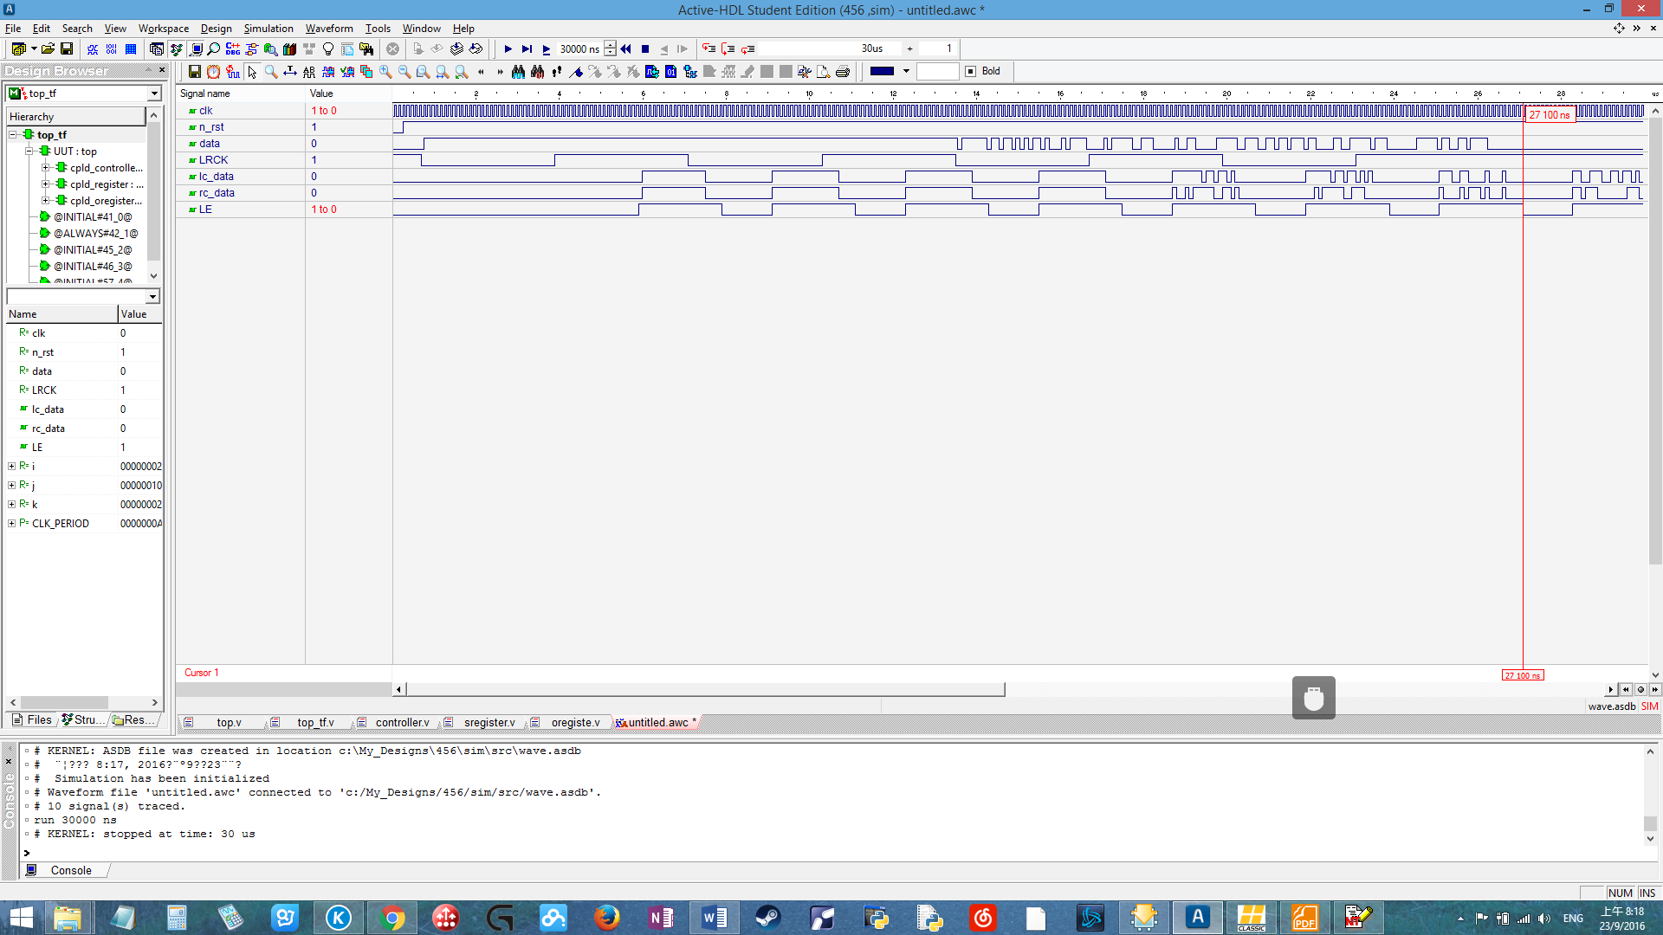

Figure 3.1.4.1: Verilog simulation result using Active-HDL

It is showing that the program function like expected with no data lose. Also the padding is correctly being added after 16 bits data for both left and right channel.

**USB Interface Result (R1)**

In the figure below are the Oscilloscope capture of the data producing by the PCM2706 circuit on the PCB. It showing that the data is successfully read in and transferred to the I2S bus.

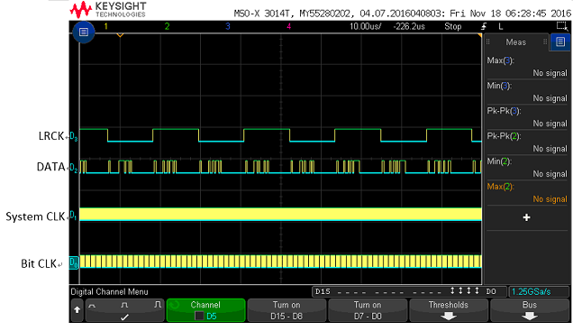

Figure 3.1.4.2: Oscilloscope capture of the data produced by the circuit

**FPGA Output(R2)**

In the figure it showing the output of FPGA. It showing that the serial data correctly separate to left and right channel with latch enable last exactly 20 clock cycle. No latch, glitch or any other problems found here.

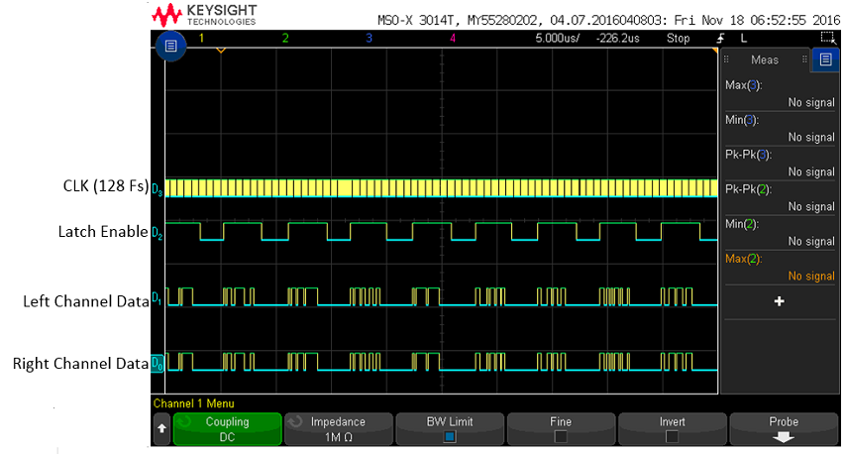

Figure 3.1.4.3: Oscilloscope capture of the data produced by FPGA

**Output from I to V converter and Reconstruction Filter (R5&R6&R7)**

The figure below showing the output at I to V converter and reconstruction filter. The filter output is much smoother compare to the first one. Also the output is 1 volt peak to peak. The first signale looks thick since the PCM1702 is producing some noise. Due to the limit stock of PCM 1702 this issue cannot be fixed by now.

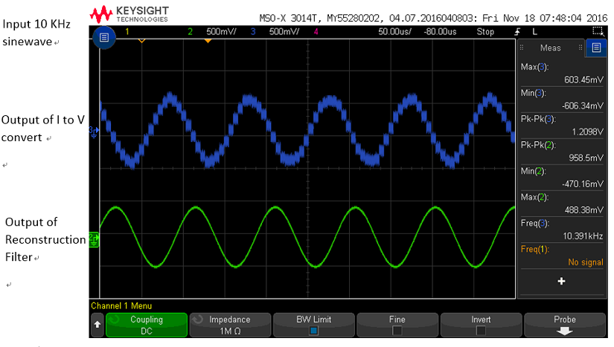

Figure 3.1.4.4: I to V converter & Reconstruction Filter output

**More Filter Output(R6)**

these two figure shows how the data behave before & after Filter. The last line is the FFT of the input & output signal. It showing that it does eliminate the noise. But there is still distortion there cause the data is near half Nyquist rate(19kHz).

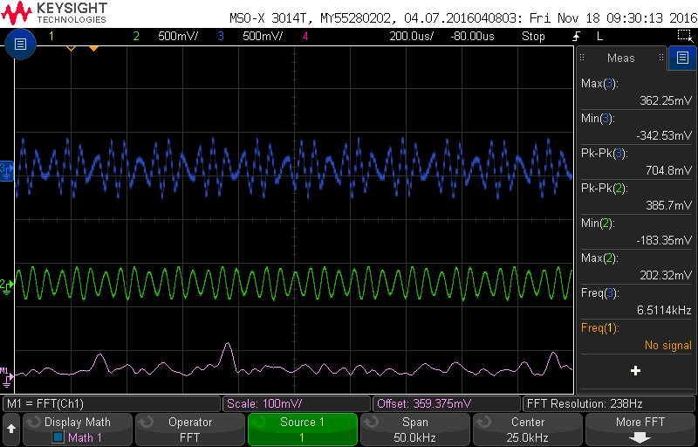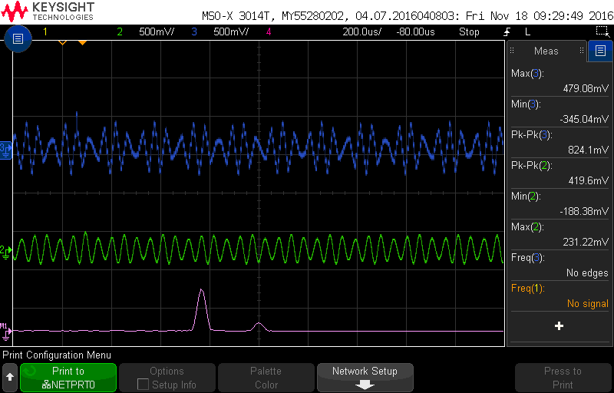

Figure 3.1.4.5: Reconstruction Filter Output

**Filter Frequency Sweep Using Matlab(R2)**

The figure below shows the frequency sweep for the filter. It shows that the filter meet all the requirement for noise, phase delay and cut-off frequency.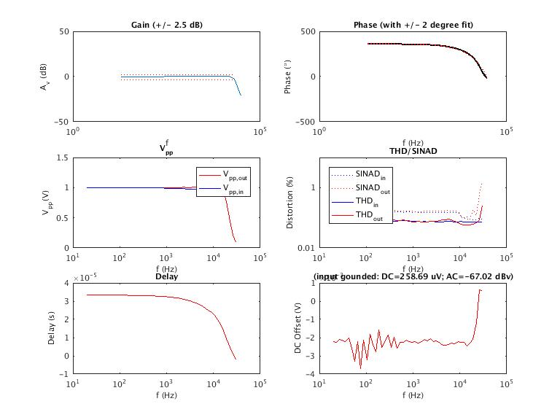

Figure 3.1.4.6: Reconstruction Filter Output

**4x Interpolation(R4)**

The FPGA will be used as a 4x interpolator. The way of interpolation is called 4 points 3 order Lagrange Interpolation. The equation of calculated the interpolation are listing below. This method is learned from a paper:

**Polynomial Interpolators** for **High**-**Quality Resampling** of Oversampled Audio by Olli Niemitalo in August 2001

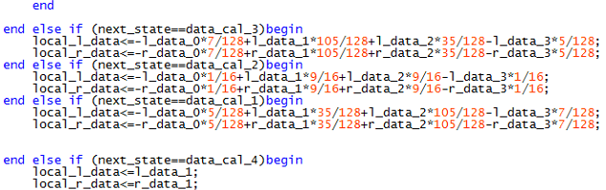

Figure 3.1.4.7: Verilog Code for Lagrange Interpolation

This interpolator would decrease the sampling noise, also have a better reconstruction quality at higher pass band frequency above 10 KHz compare to linear interpolation.

**Schematic & PCB**

Below are my altium schematic

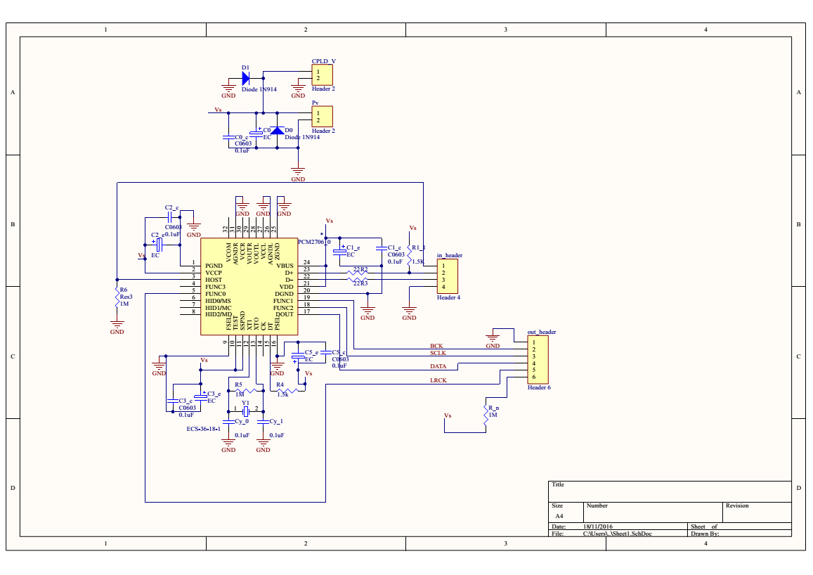

Figure 3.1.4.8: PCM2706 Schematic

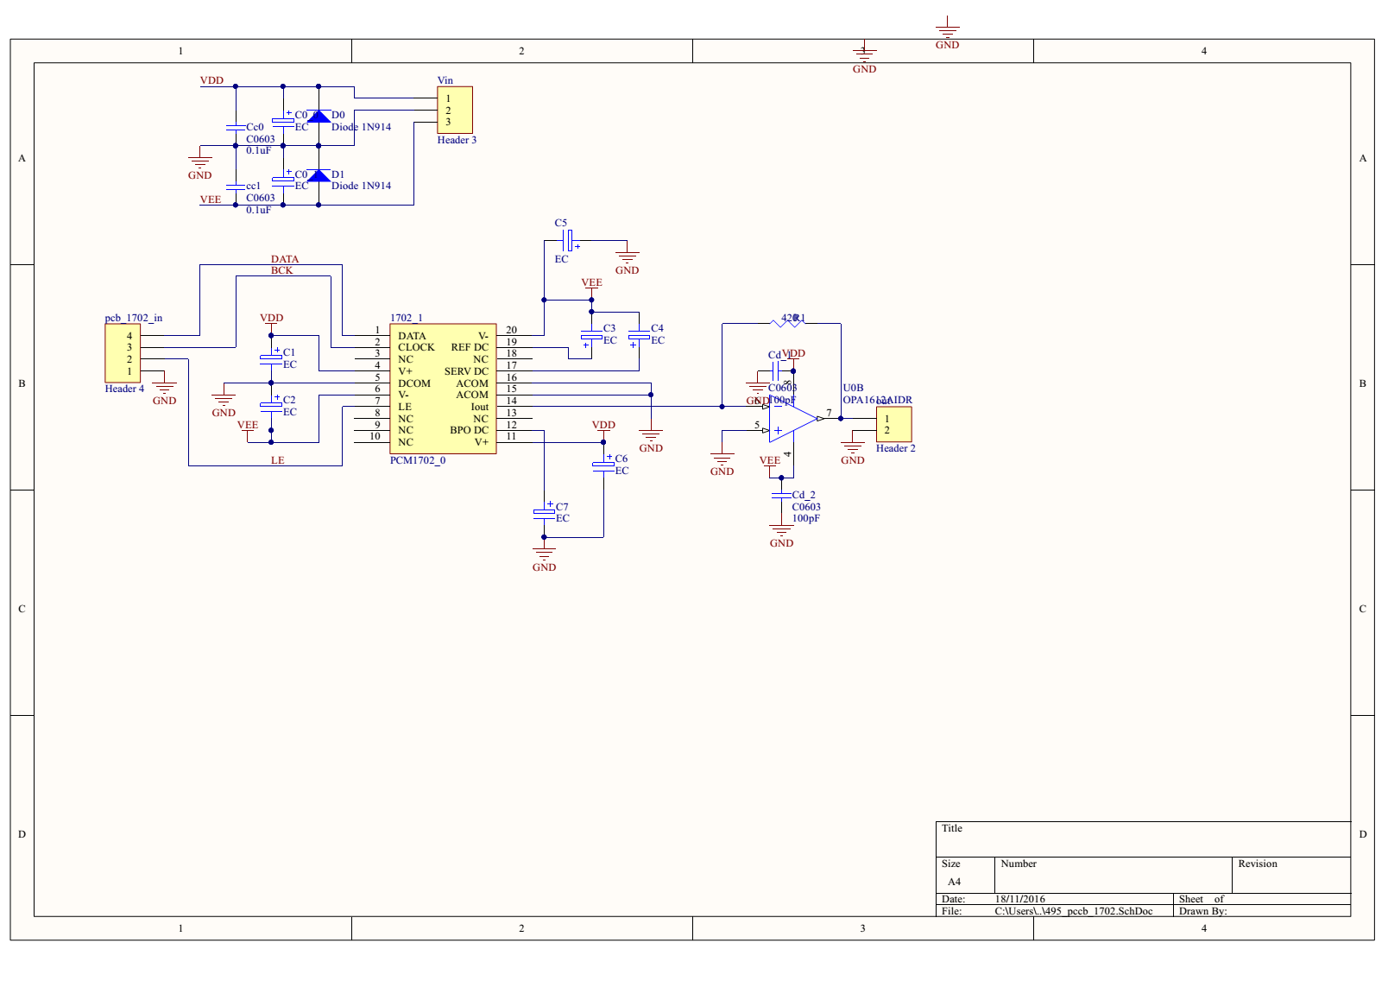

Figure 3.1.4.9: PCM1702 Schematic

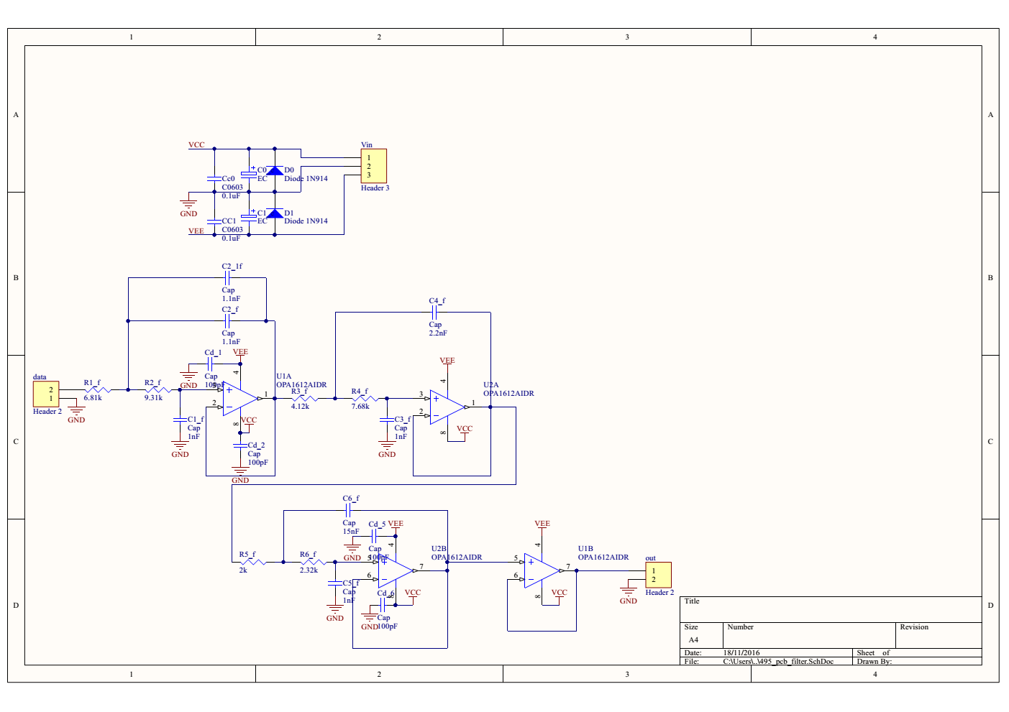

Figure 3.1.4.10: Filter Schematic

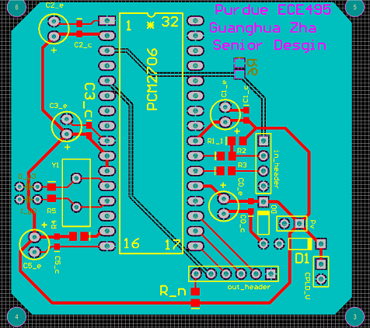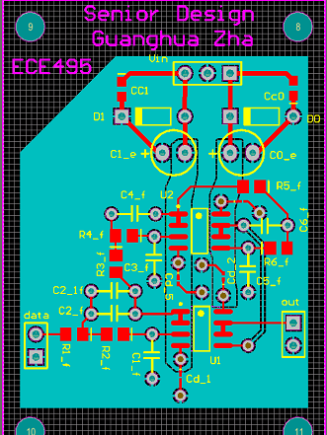

Figure 3.1.4.11: PCM2706 PCB Figure 3.1.4.12: Filter PCB

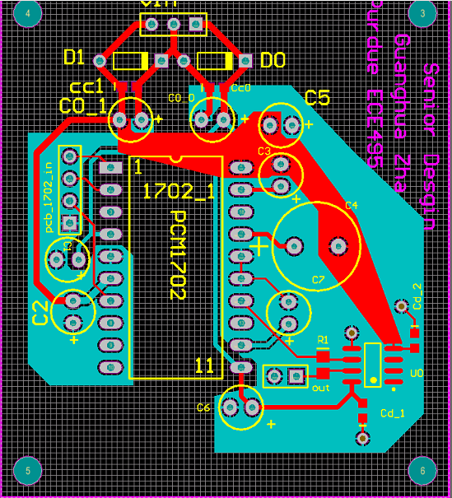

Figure 3.1.4.12: PCM 1702 PCB

### 3.1.5 Testing Plan

Tools: Oscilloscope, wires, computer

Procedure:

1. Connect the system to the computer and power the system.

2. Observe if the LED around power pin turn on.

3. Output some signal(music) from the computer to the system. Check if the DAC is selected as default output devise.

4. Use oscilloscope to measure output of PCM 2706, check if Data bus, bit clock and system clock have signals(R1,R2,R3)

5. Use oscilloscope to measure the output of I to V converter and filter. Check if signal match ( R6 ,R7)

6. Use oscilloscope to measure and plot the output of FPGA. (R4, R5)

### 3.1.6 Subsystem Phototype

Top layer is the filter, bottom layer is two PCM1702. In the middle is the PCM 2706. Right side is a linear regulator that takes +-12 V input and output +-9, +-5 and 3.3 V. Left corner is the FPGA.

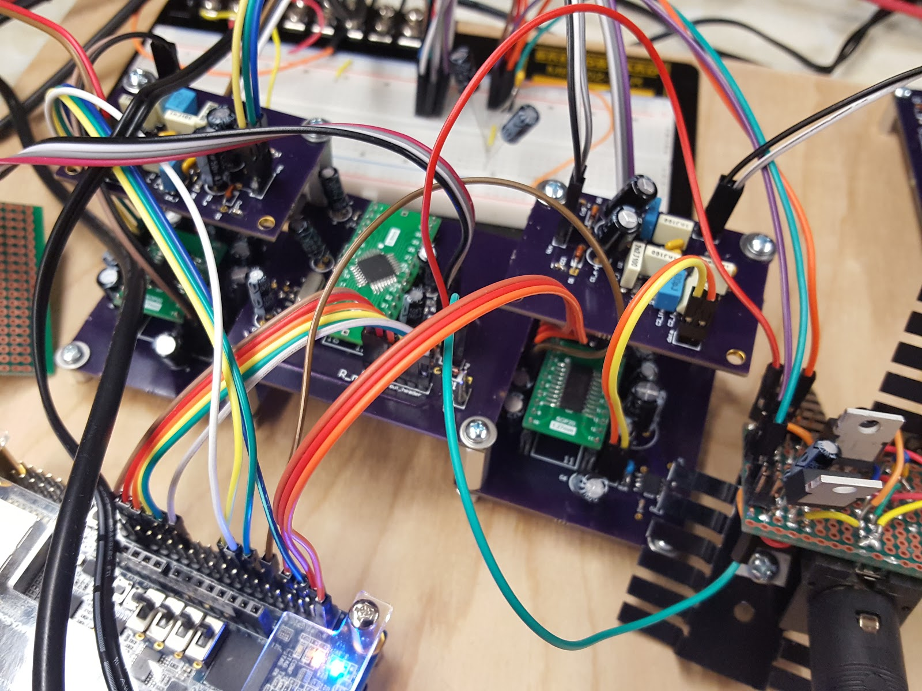

The system is now powered by my linear regulator. The PCB in the far end is used for the connection between power regulator and PCBs.

Power(One Channel Operation): 3.3V \* 23 mA + 5V \* 30 mA + |-5V| \* 50 mA = 475.9 mW

## 

## 

## 

## 

## 

## 

## 3.2 VU + GUI Controls

### 3.2.1 Subsystem Requirement

1. Able to read the user command changing volume(1-100%), balance(left/right, 1-100%), treble(-6dB ~ 6dB), mid(-6dB ~ 6dB) and bass(-6dB ~ 6dB).
2. Able to show the changed values for each parameter.
3. Able to show VU meter of left and right signal amplitude to the user with a rate higher than 2Hz.
4. TIVA must receive signal with > 0V.

With VU/GUI the user can manipulate and see the parameters with sliders(Fig. 3.2.5) on touchscreen. The user can manipulate the 5 different parameters with two panels. The first panel contains Volume and Balance slider bars with 100% range for both of them. If the user push the + button which places at right bottom corner, the panel goes to the second page, where the user can control Bass, Treble and Mid with range of -6dB ~ +6dB. The user can go back and forth of these 2 panels by + and - sign at the bottom. On the other hand, to perform the user command, TIVA will identify the command and send SPI(Serial Peripheral Interface) signal to digipot(digital potentiometer). To use less number of pins, 3 to 8 digital multiplexer is used. It receives 3 enable signals from TIVA and send 6 chip select signals to digipots. The chip select signal will enable or disable the digipot. All the digipots receive the same CLK and SDI signal from TIVA. With this mechanism, the user can control 5 different parameters with simple GUI anytime TIVA will receive the signal from Amplifier Control via rectifiers. After Tiva receives the converted signals from rectifiers, the touchscreen can visualize the signals with VU(Volume Unit) meter by two slider bars to show how high the signal level is up until 106dB. However, TIVA cannot receive negative signal. To prevent circuit destruction in TIVA, two full wave rectifiers are going to be used for converting negative parts to positive. The processes are visualized in Fig 3.2.1 and Fig. 3.2.2 as a block diagram and activity diagram.

### 

### 

### 

### 

### 

### 3.2.2 Subsystem Block Diagram



Figure 3.2.2.1 Block Diagram

### 3.2.3 Schematics and Flow chart



Figure 3.2.3.1 Flow Chart

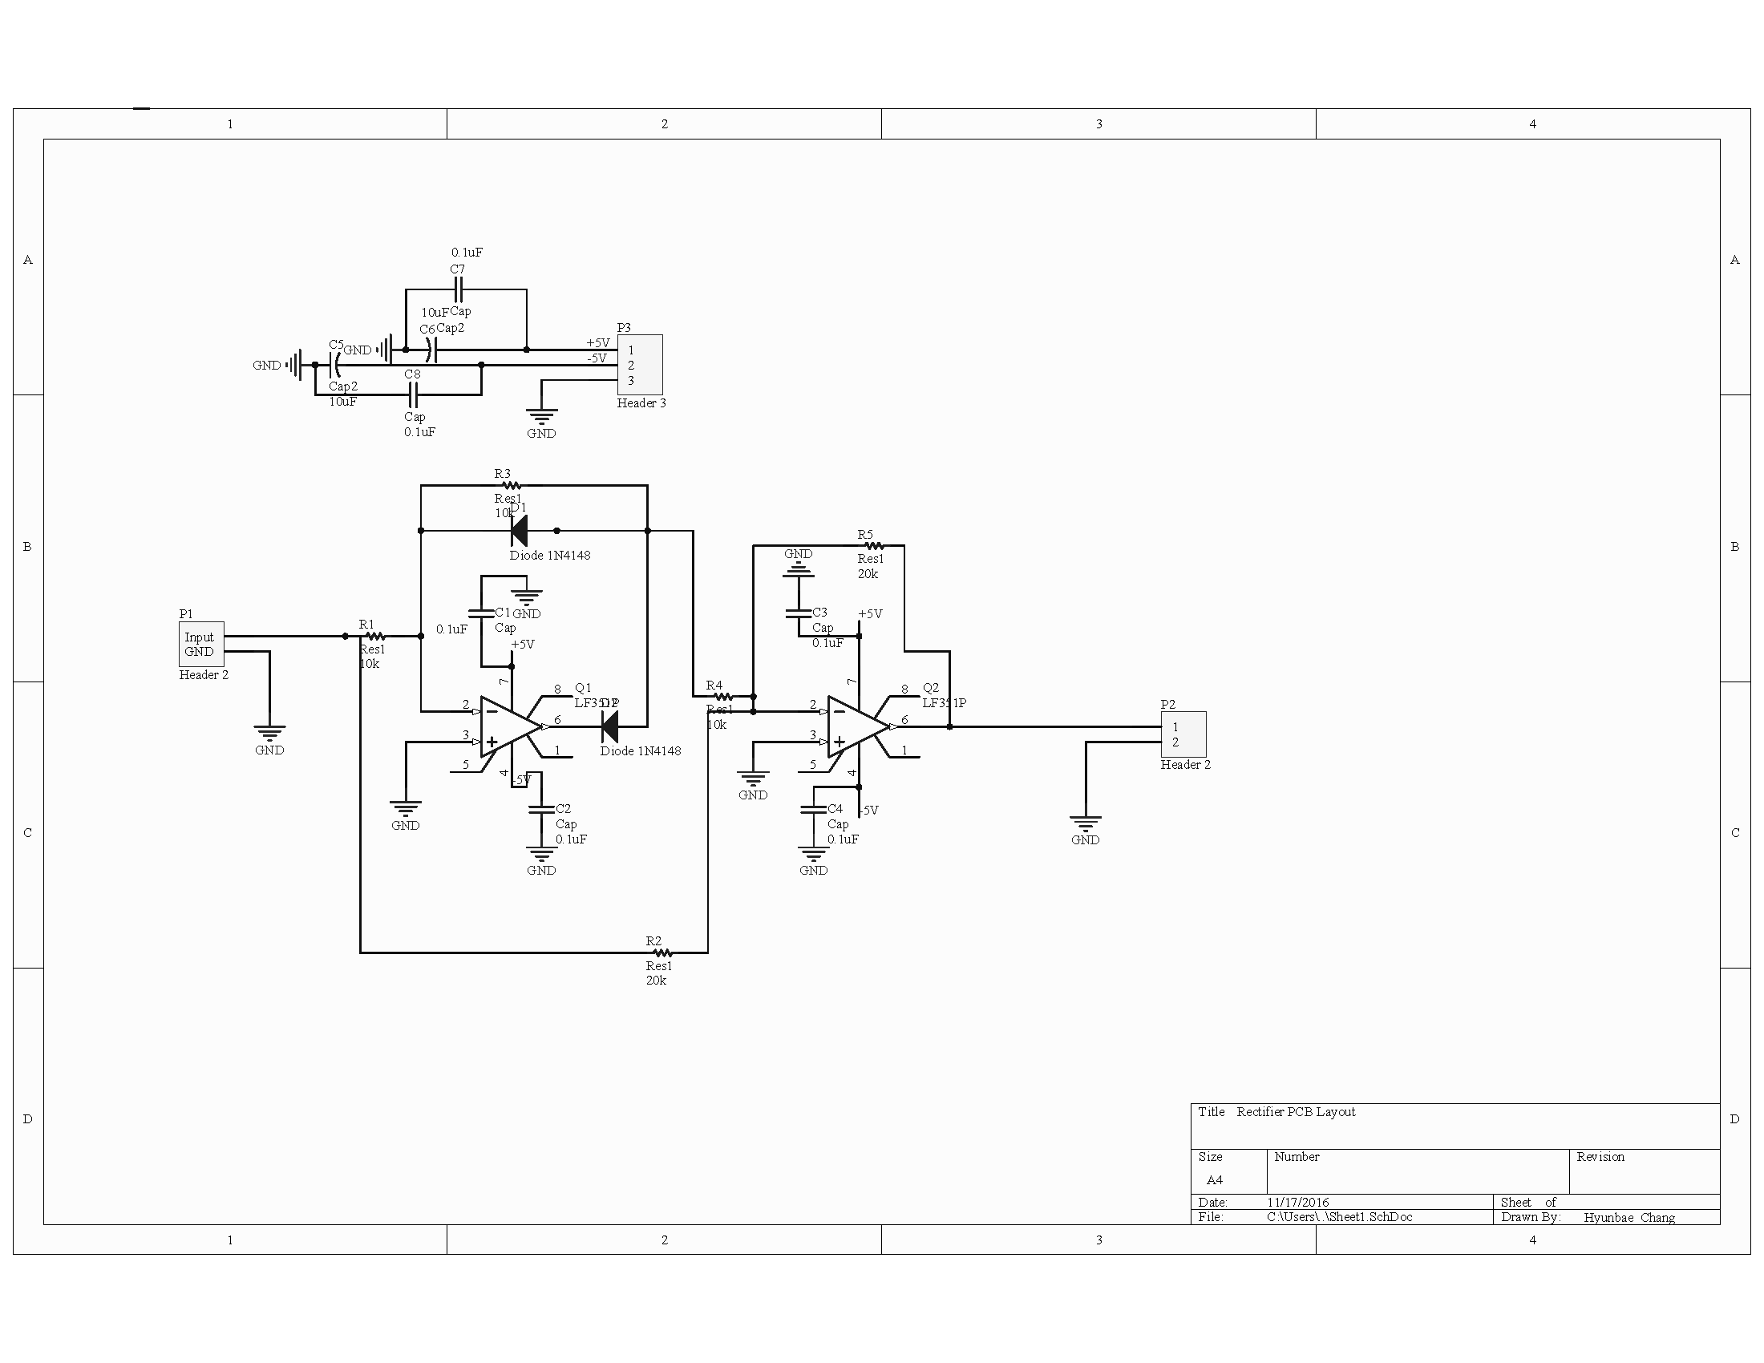

Figure: 3.2.3.2 Rectifier Schematic

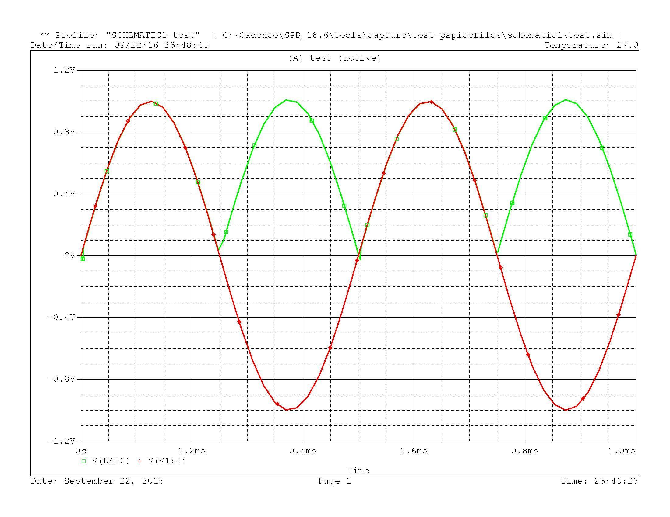

Figure: 3.2.3.3 Rectifier Input(red) and Output voltage(green)

### rectifier.png

Figure: 3.2.3.4 Rectifier output with Oscilloscope

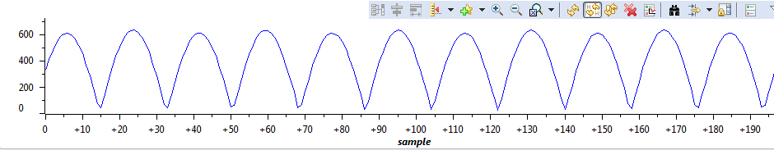

Figure: 3.2.3.5 ADC Input to Tiva from Rectifier(100Hz frequency)

### Tiva PCB layout.png

Figure 3.2.3.6 TIVA Schematics with Demux and Digipot

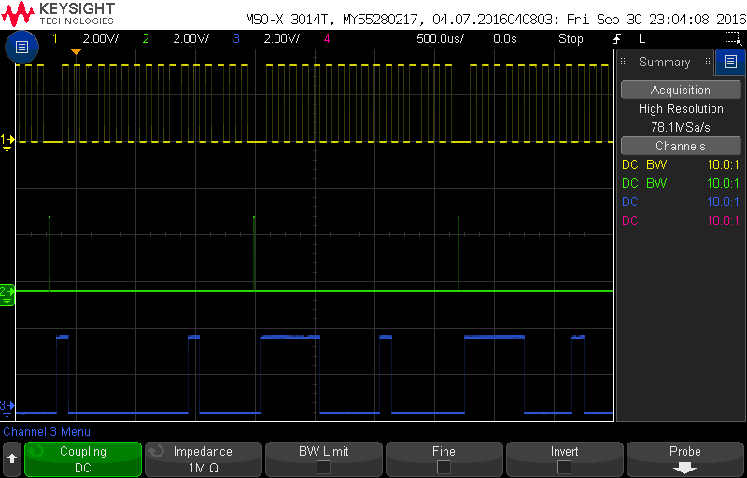

Figure 3.2.3.7 SPI signal received to Digipot from TIVA

### 

Figure 3.2.3.8 Volume(%) vs. Digipot resistance(kohms)

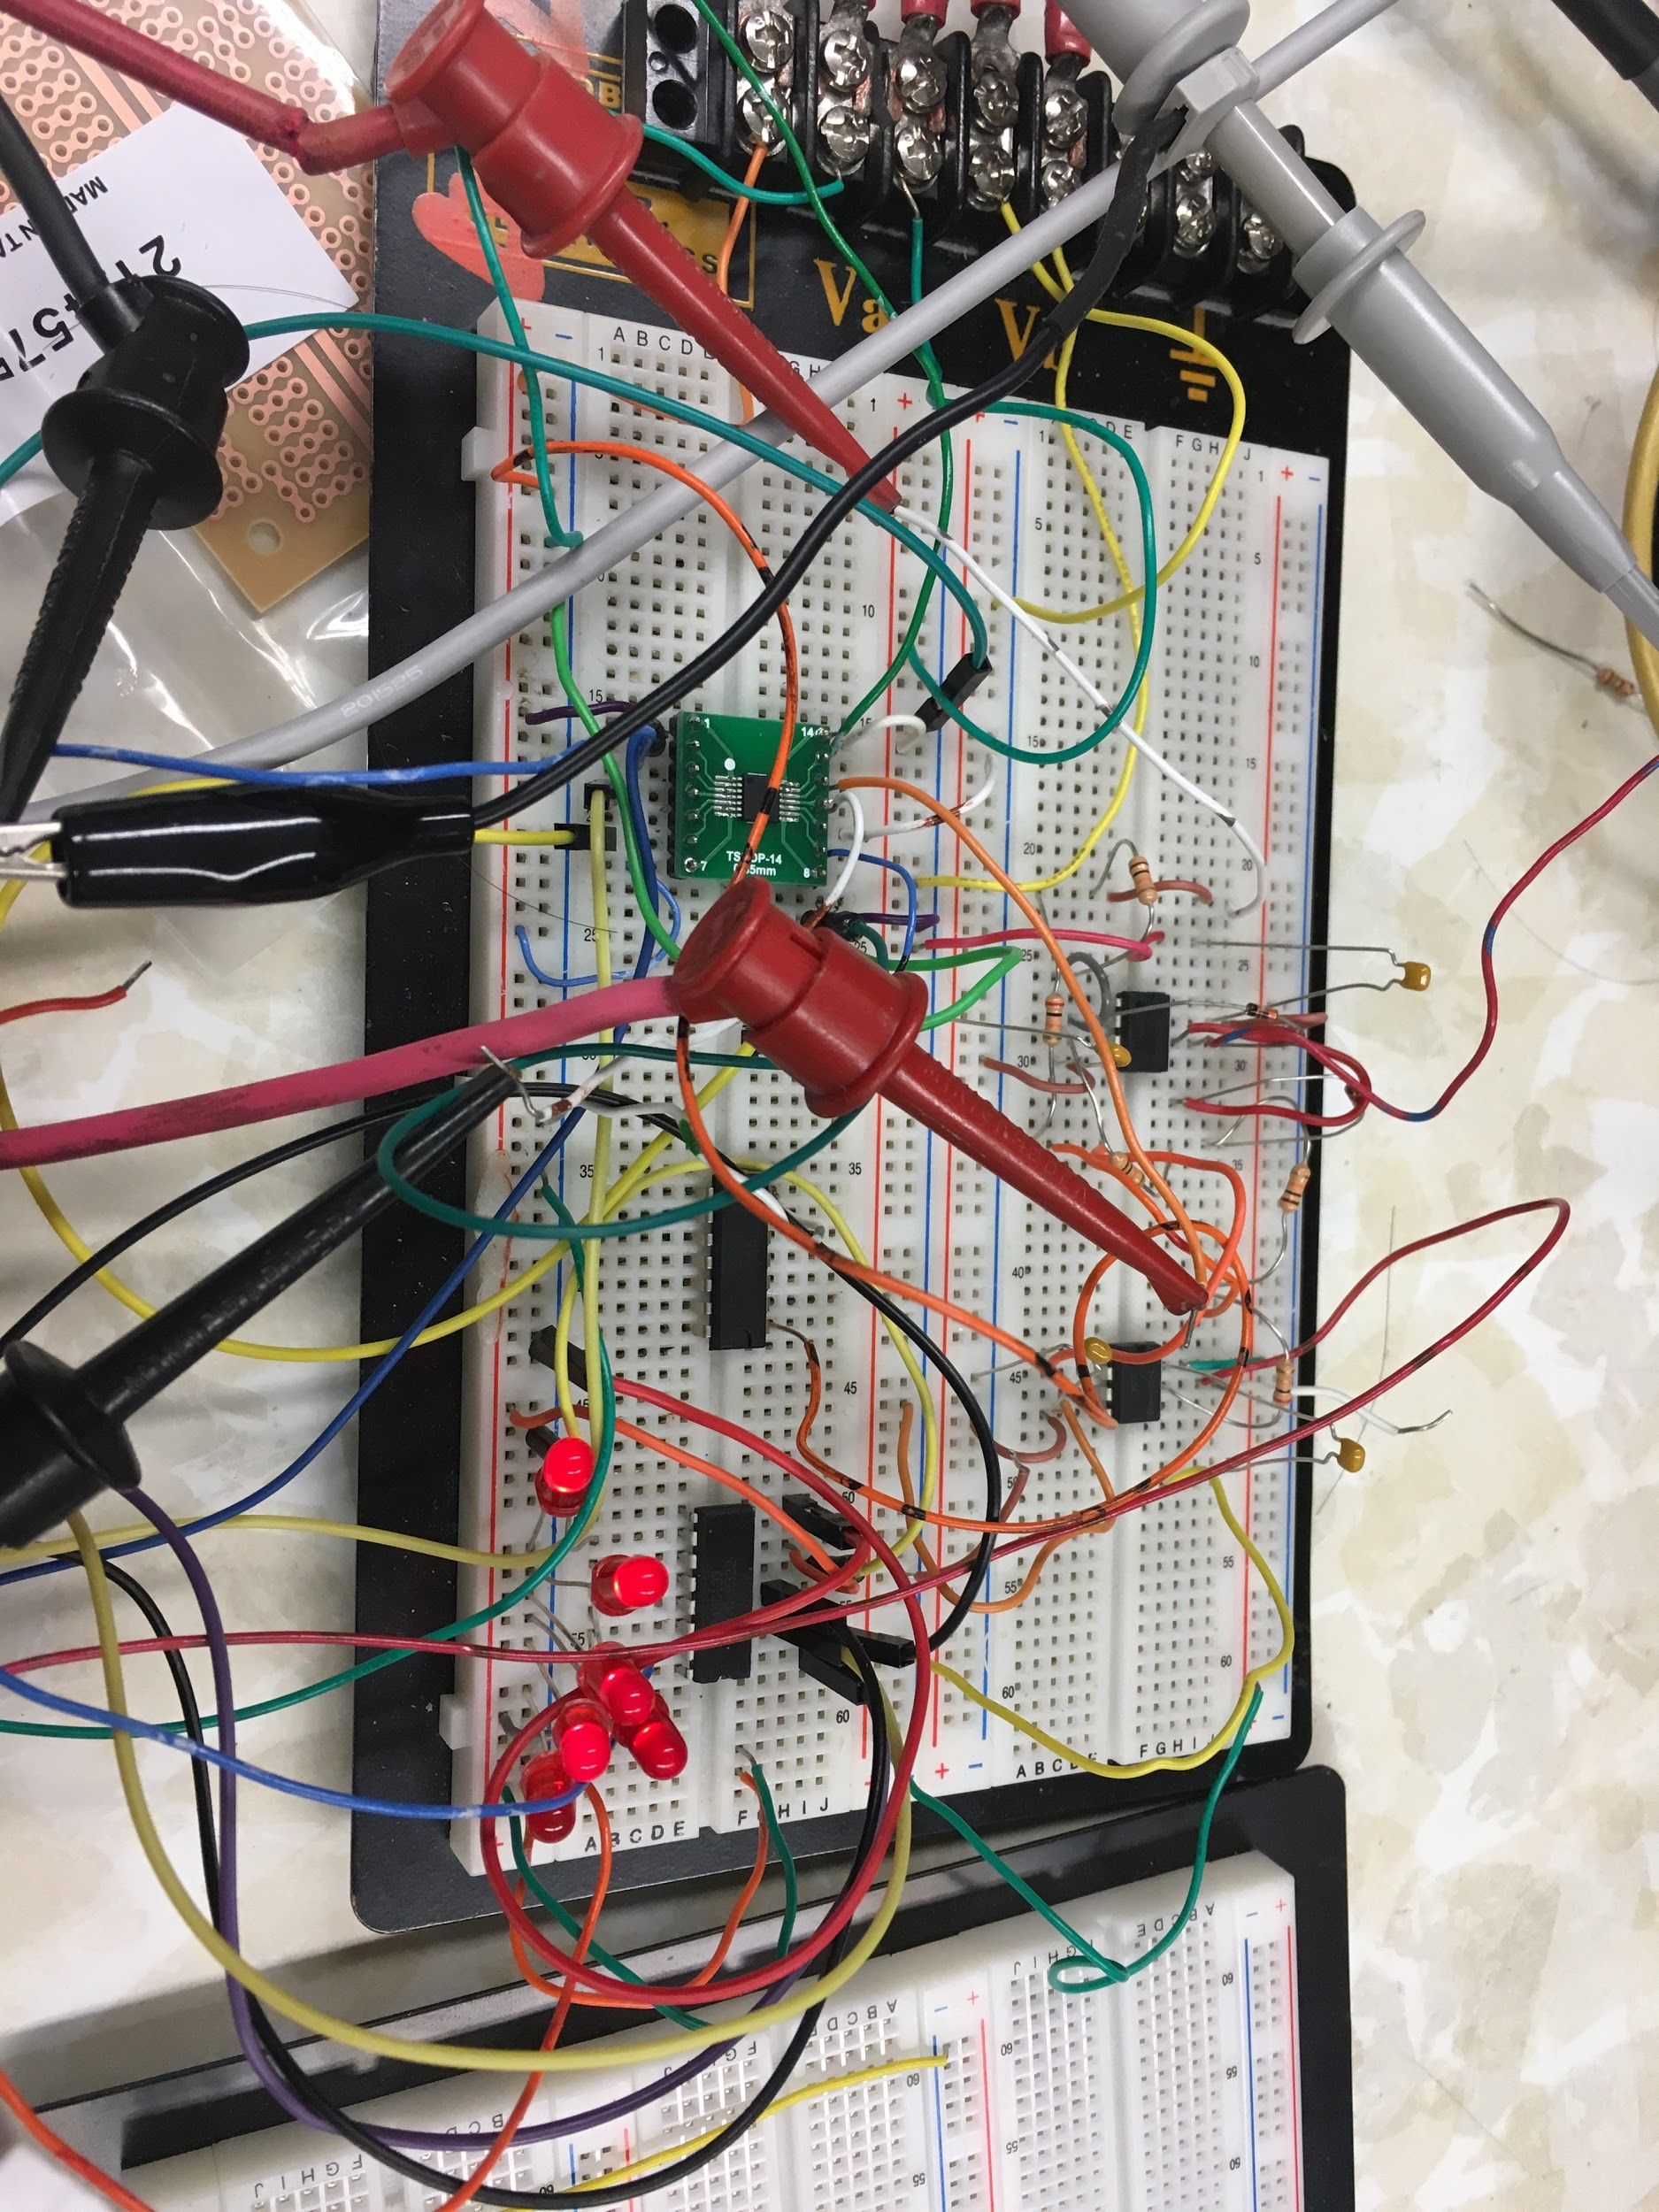

Figure 3.2.3.9 Demux corresponding to signals from TIVA

### 3.2.4. Testing Plan

Equipment that will be used:

1. Power Supply: Agilent E3631A
2. Oscilloscope: Keysight MSO-X 3014T
3. Function/Arbitrary Waveform Generator: Agilent 33220A
4. Digital Multimeter (DMM): Agilent 34401A
5. Touch Screen Module: TIVA TMC123GXL
6. Able to read the user command changing volume(1-100%), balance(left/right, 1-100%), treble(-6dB ~ 6dB), mid(-6dB ~ 6dB) and bass(-6dB ~ 6dB).

* The resistance of potentiometer will be measured. If the resistance decreases, the parameter increases, if it increases, the parameter decreases. With the result, it can be checked that the requirement is met or not.

1. Able to show the changed values for each parameter.

* With programming, the changed values is going to be printed on the touch screen. With moving the sliders, going to test the values reflect the state of slider.

1. Able to show VU meter of left and right signal.

* With ADC plot in Code Composer Studio, Tiva can get positive voltage signal from the rectifiers and show the volume level with the slider bars.

1. TIVA must receive signal with > 0V and >2Hz.

* The rectifier circuit was built and the output of it was tested with oscilloscope. It was positive with the same amplitude of input.
* The function generator would send the signal with frequency bigger than 2 Hz, and if VU meter with TIVA touch screen changes its shape corresponding to the signal, this requirement can be achieved.

1. Digital Multiplexer(Demux) receives the signal from Tiva to vary Chip Select Signals(CS) and send the outputs to Digipots as CS signals.

* Three outputs from Tiva and CS signal to Demux are passed to Demux as inputs, and a Digipot received an output from Demux to test the outputs from it.
* The Digipot functions normally with the all the outputs from Demux so that Demux receives proper signals from TIVA before vary and send the CS signal to digipot

### 3.2.5 Prototype Photos

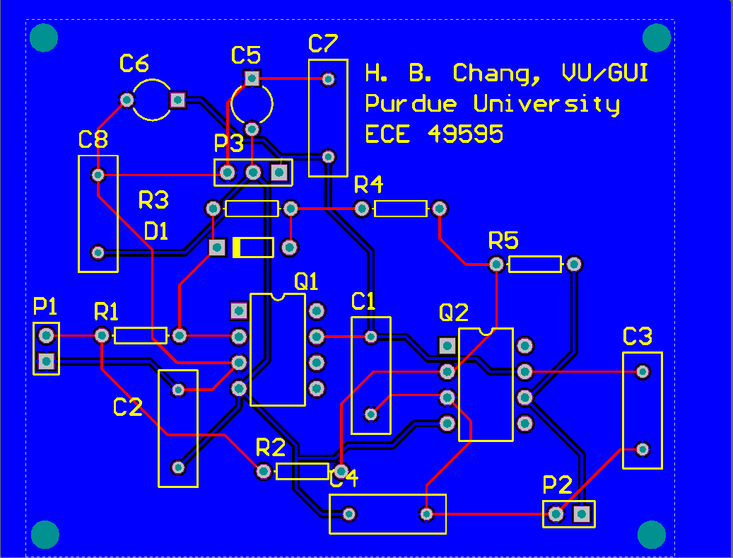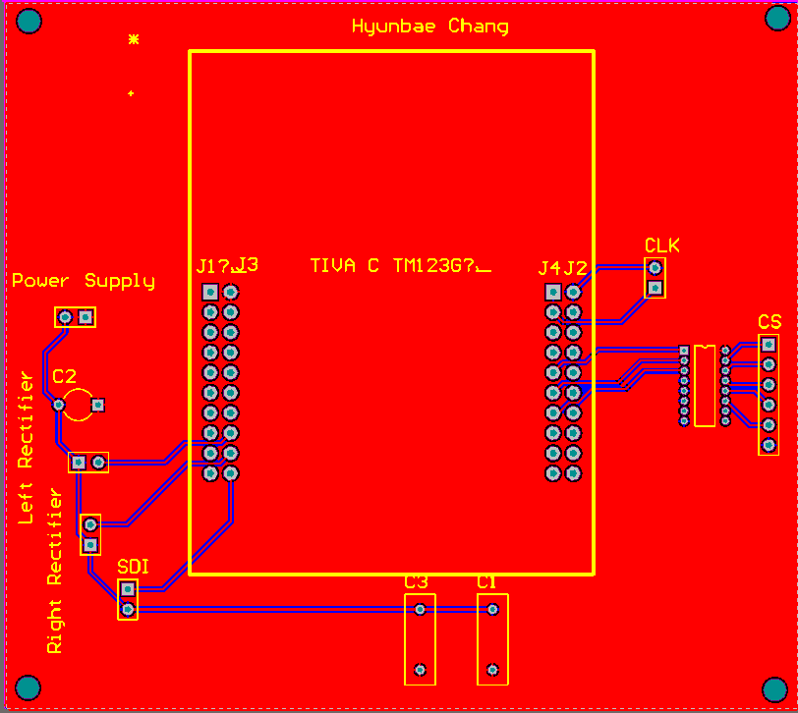

Figure 3.2.3.11 PCB designs for full wave rectifier and TIVA

**3.2.5 Parts Costs and Power Requirements**

**3.2.5.1 Parts Costs**

6 \*digipot(MCP41HVX1) = $8.46

EK-TM4C123GXL(TIVA) = $12.99

BOOSTXL-K350QVG-S1(Kentec Touchscreen) = $24.99

PCB(for rectifier) = $24.65

PCB(for TIVA and Demux) = $61.95

Total = $133.04

**3.2.5.2 Power Requirements**

∓ 5V for demux, digipots and rectifiers

+3.3V for digipots

## 3.3 Amplifier Controls

### 3.3.1 Subsystem Requirement

1. Volume: Full range down to 0
2. Bass: minimum ±6dB
3. Mid: minimum ±6dB
4. Treble: minimum ±6dB
5. Balance (Left/Right): Full range from 100% down to 0%
6. Op-Amp based filter designs
7. Analog Circuit Simulation
8. Analog Circuit Constructions

The Volume, Balance, Bass, Mid, and Treble will all be controlled by digipots which will be controlled on the touchscreen by the VU/GUI subsystem. For the volume the Digipot along with an inverted op amp (all op amps used are TL084CN) will control the output to range from 0-1V pk-pk. The balance will just use a digipot where one of the end pins is connected to ground (one channel is pin 1 to ground and the other channel has pin 3 to ground) and the output coming from the center, so as one channel goes to 100% the other will go to 0%. The Bass, Mid, and Treble are all designed the same with digipots and an inverted op amp to control the gain. The capacitors in each band pass filter determine where the frequency cut offs will be so that they are in the desired frequencies.

### 

### 

### 

### 

### 3.3.2 Subsystem Block Diagram

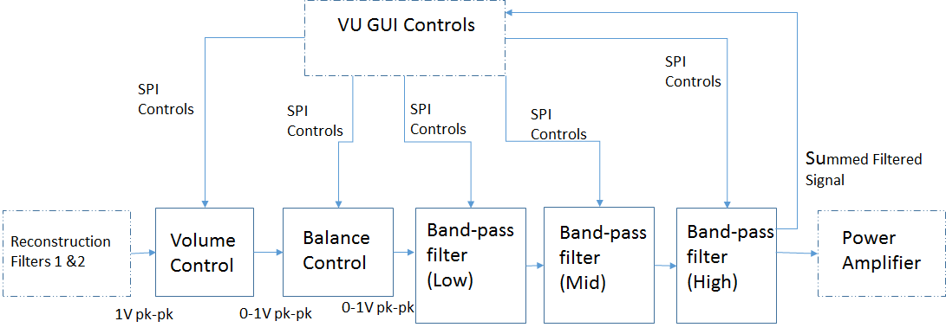

Figure 3.3.2.1: Subsystem block diagram (one headphone)

### 3.3.3 Design/Schematic

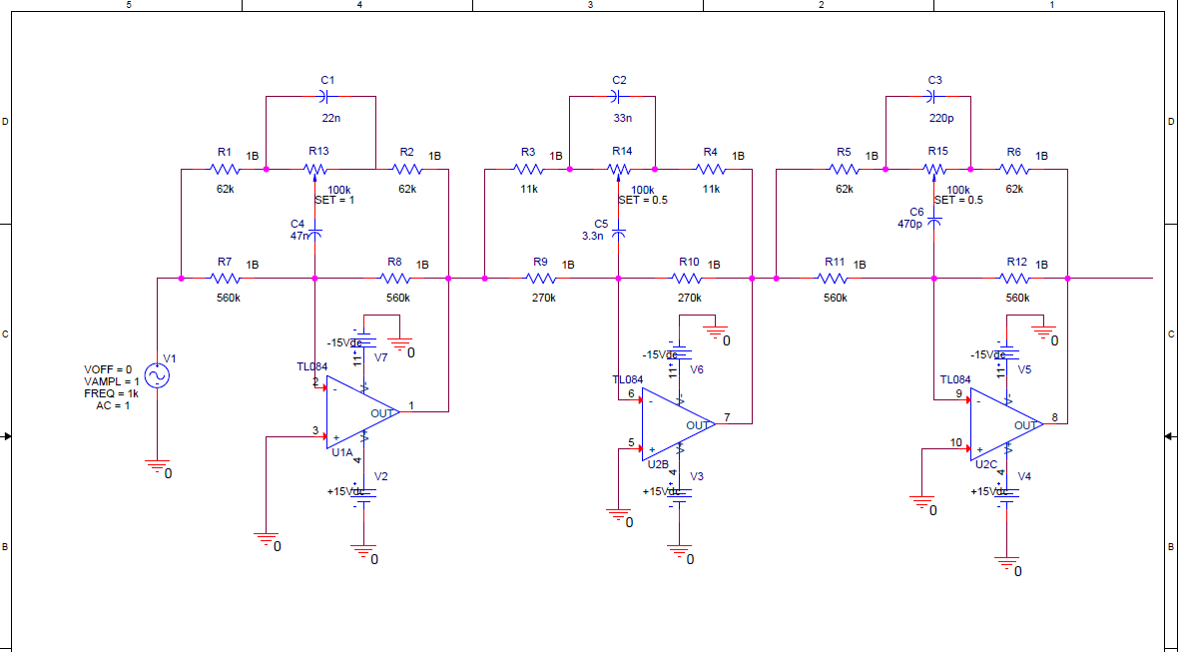Figure 3.3.3.1: Schematic for Amplifier Controls for Bass, Mid and Treble in one headphone

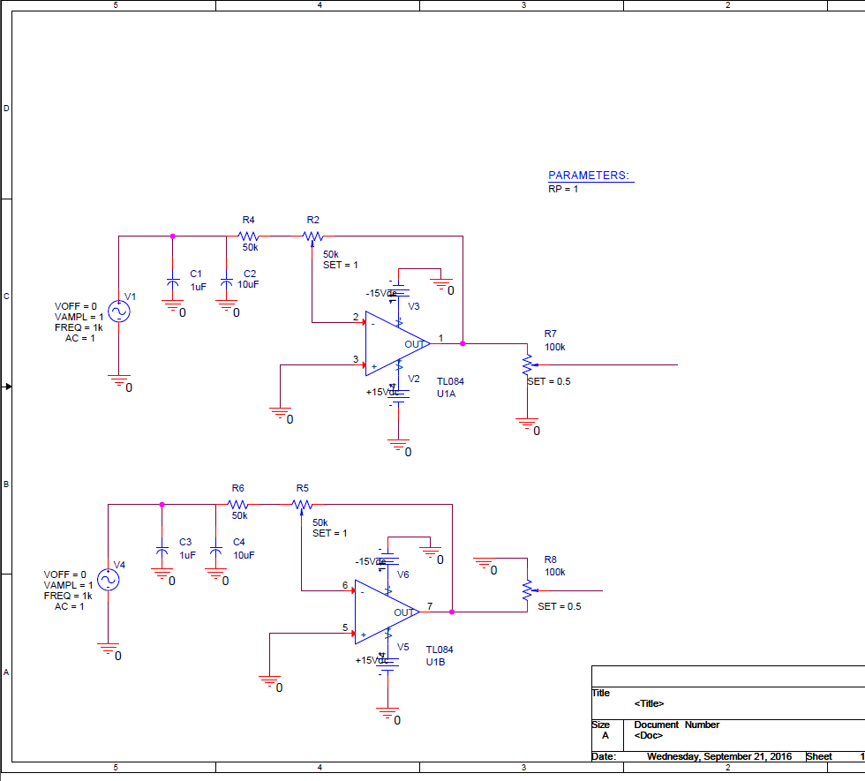

Figure 3.3.3.2: Schematic for Amplifier Controls for Volume and Balance for both headphones

### 3.3.4 Pspice Simulation Results

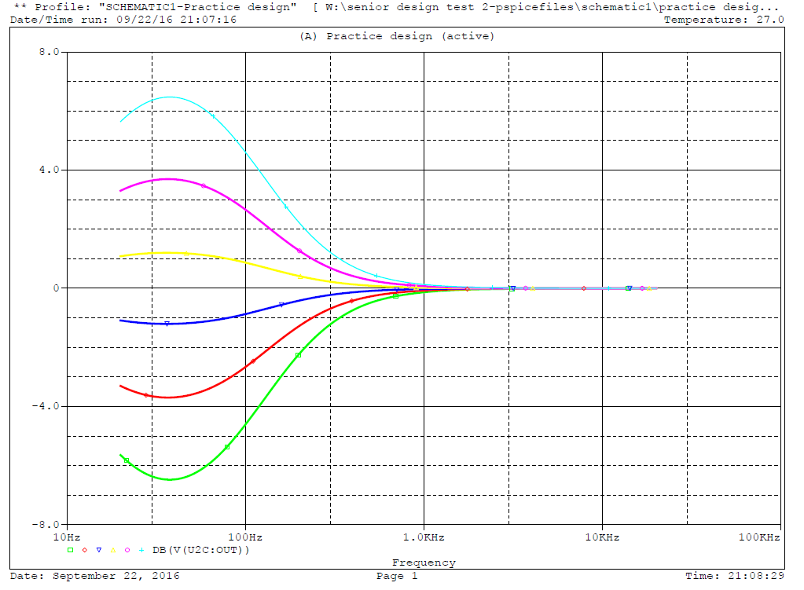

Figure 3.3.4.1: Gain vs Frequency for First Band Pass Filter

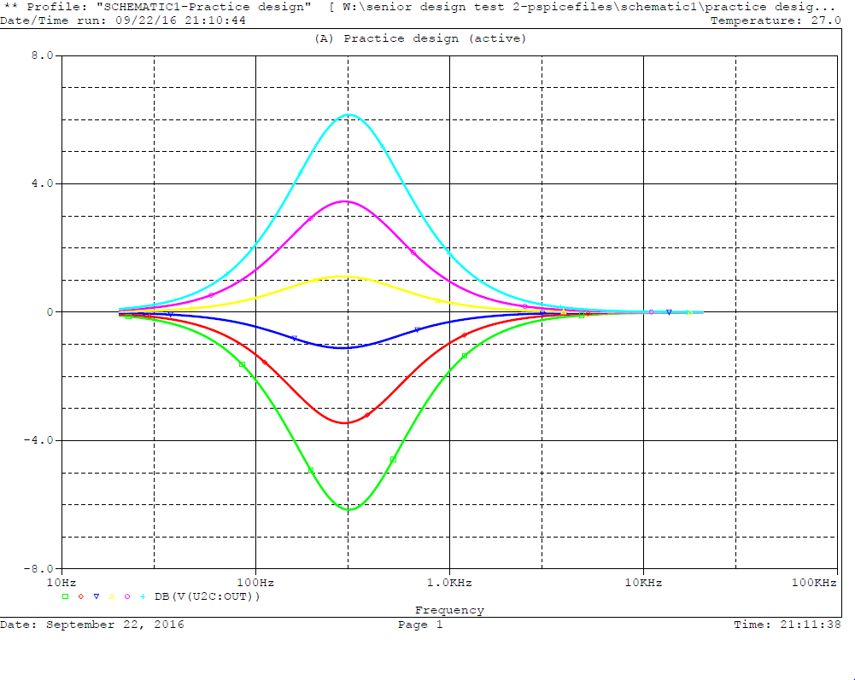

Figure 3.3.4.2: Gain vs Frequency for Second Band Pass Filter

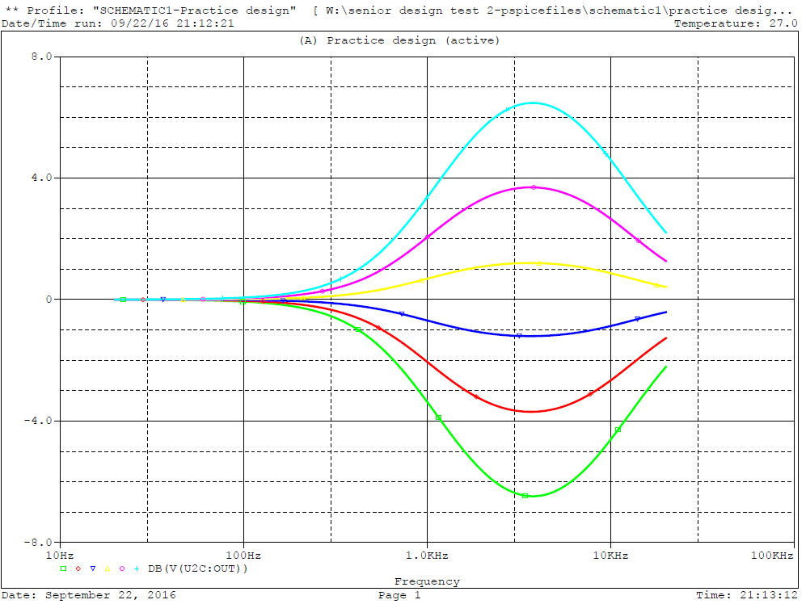

Figure 3.3.4.3: Gain vs Frequency for Third Band Pass Filter

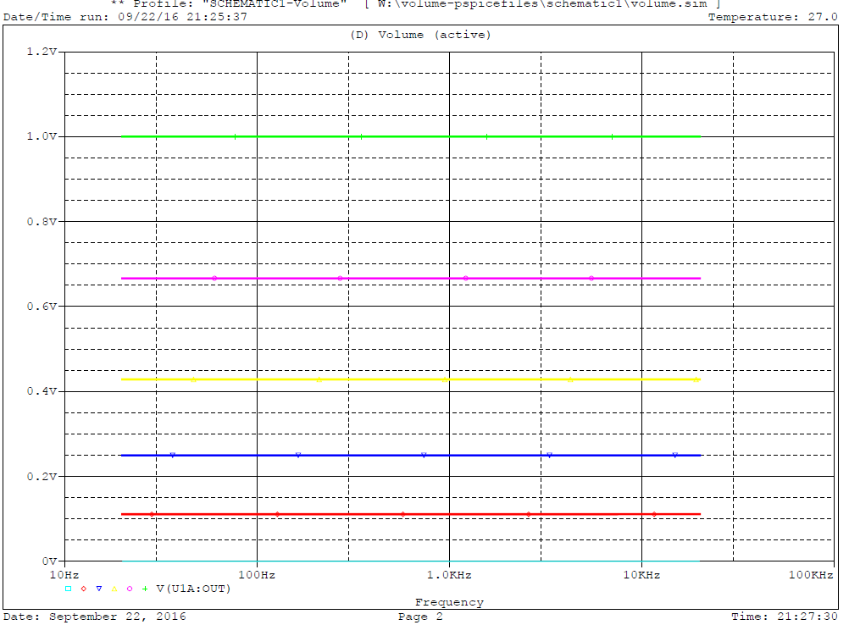

Figure 3.3.4.4: Voltage vs Frequency for Volume and Balance Control

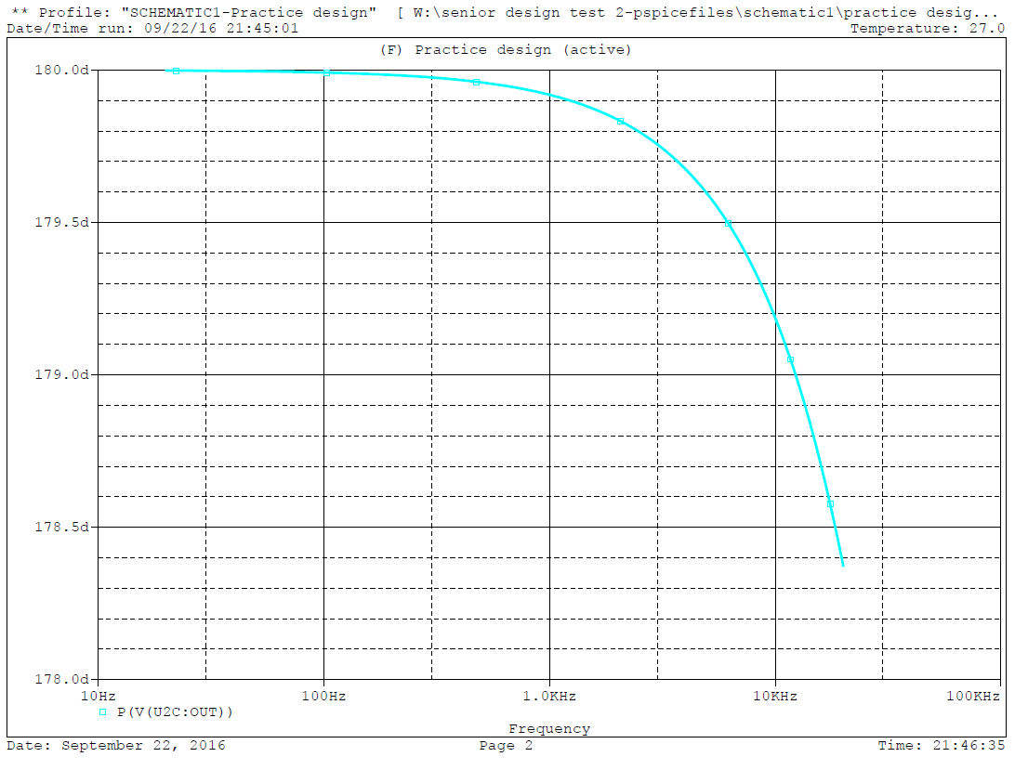

Figure 3.3.4.5: Phase at Flat Response

### 3.3.5 BreadBoard circuit Prototype

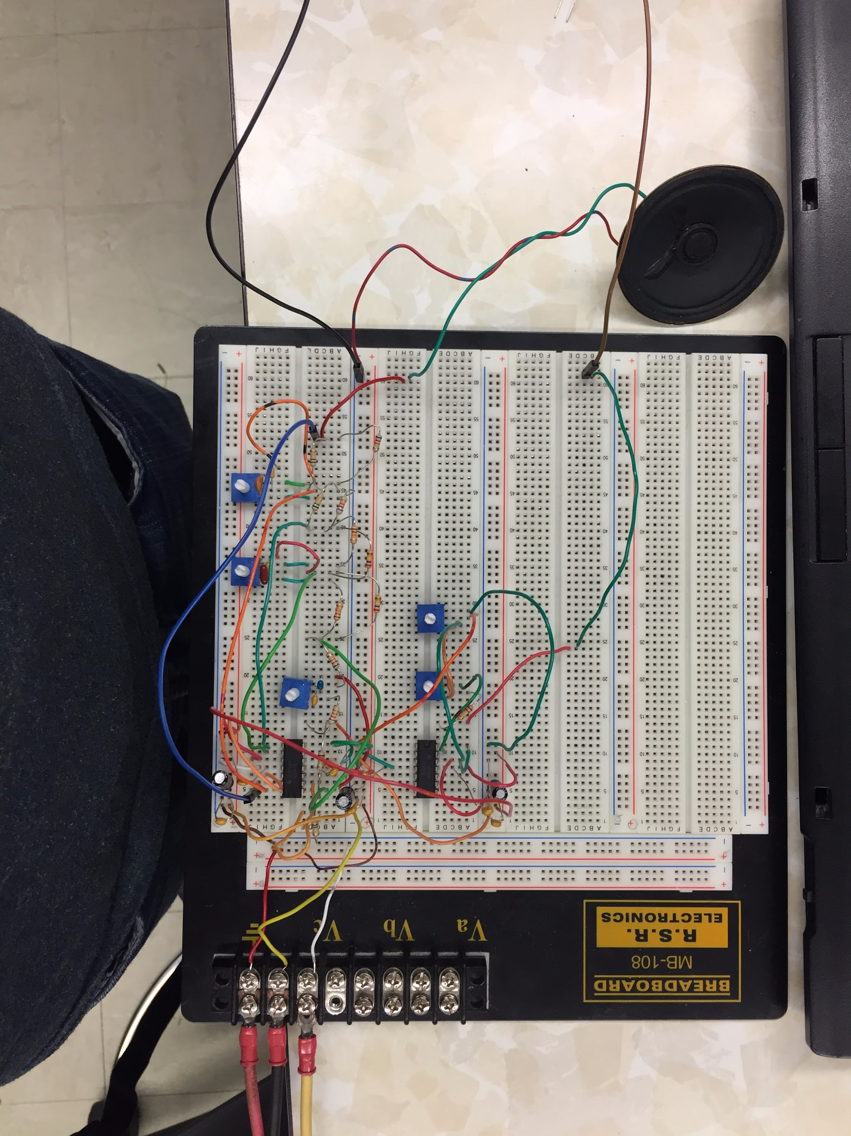

Figure 3.3.5.1: Circuit Design on Breadboard (Volume, Balance, bass, mid, and treble for one headphone)

### 3.3.6 Results (Breadboard)

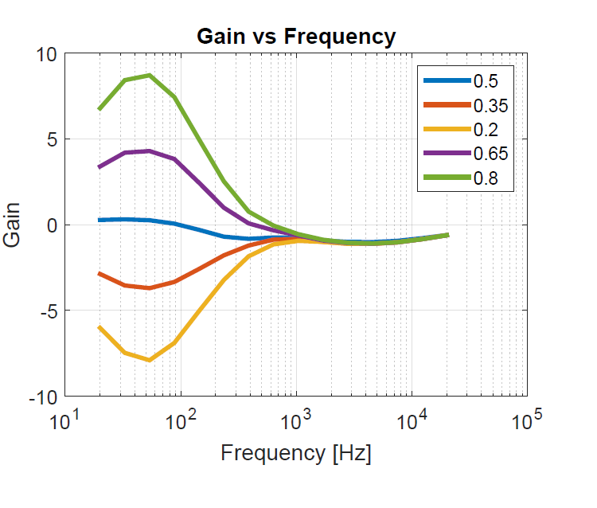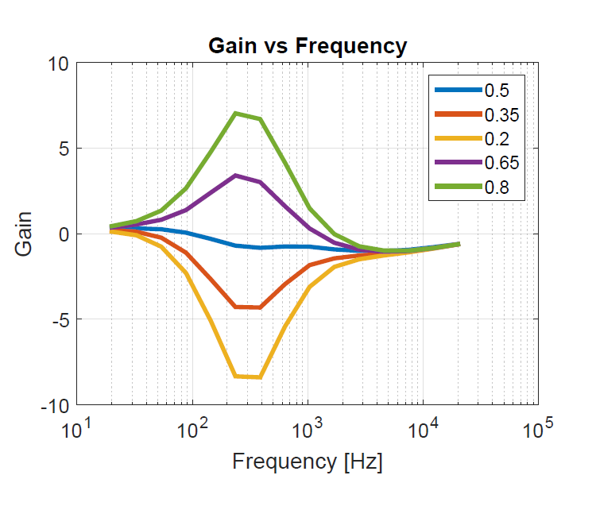

Figure 3.3.6.1: Gain vs Frequency for First Band Pass Figure 3.3.6.2: Gain vs Freq. for second Band Pass

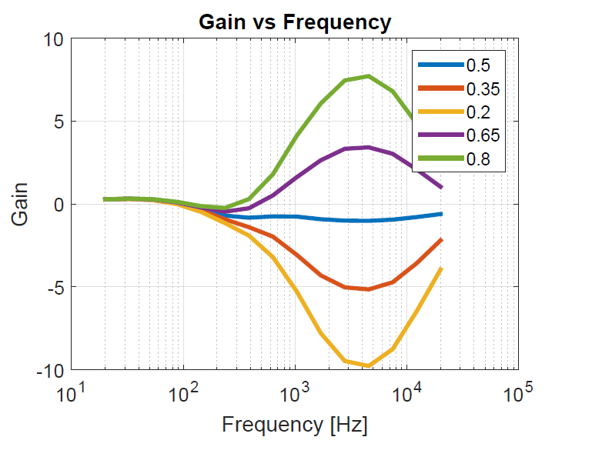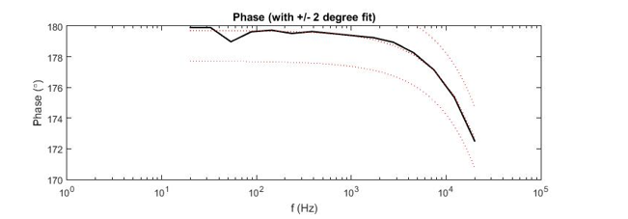

Figure 3.3.6.3: Gain vs Freq. for Third Band Pass Figure 3.3.6.4: Phase vs Freq. at Flat Response

### 3.3.7 PCB Schematic: Altium

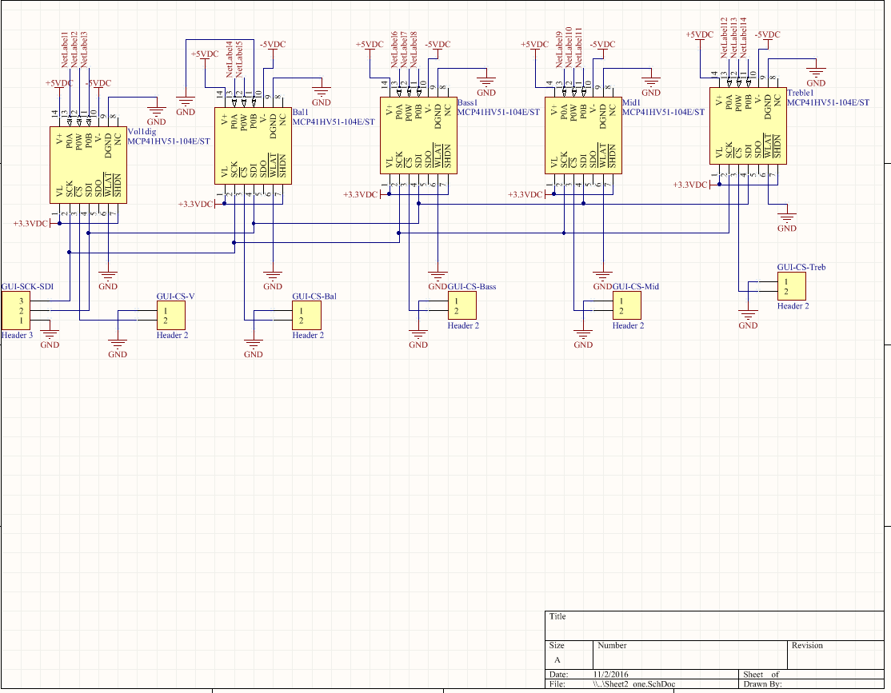

Figure 3.3.7.1: Altium Schematic of Digipots for one headphone

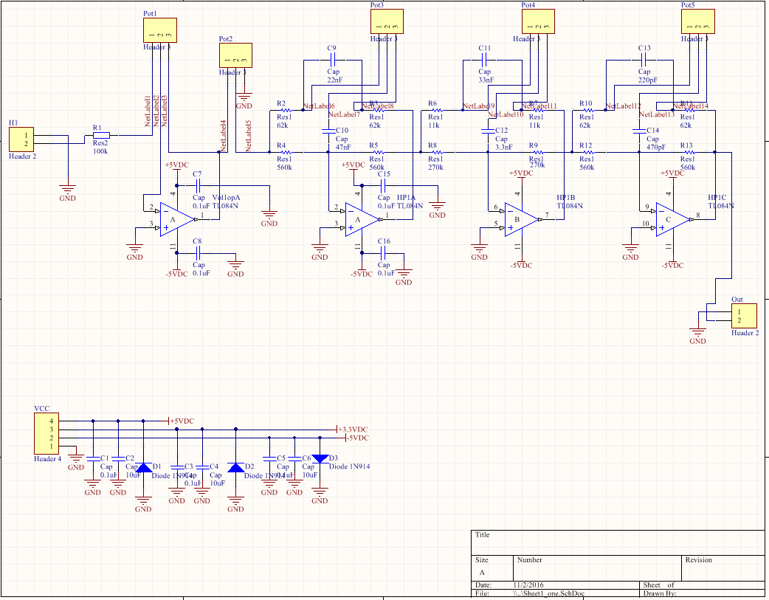

Figure 3.3.7.2: Altium Schematic of Volume, Balance, Bass, Mid and Treble for one headphone

### 3.3.8 PCB Layout

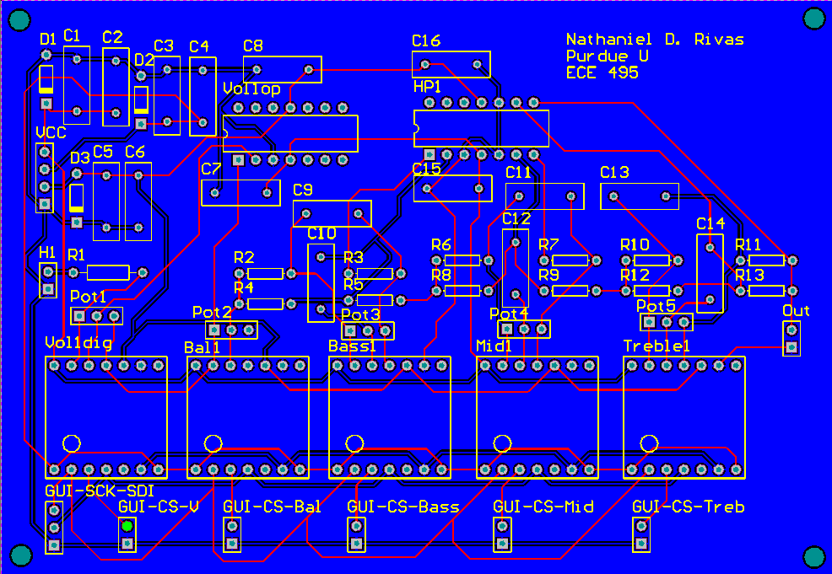

Figure 3.3.8.1: PCB Layout of Amplifier Controls for one headphone

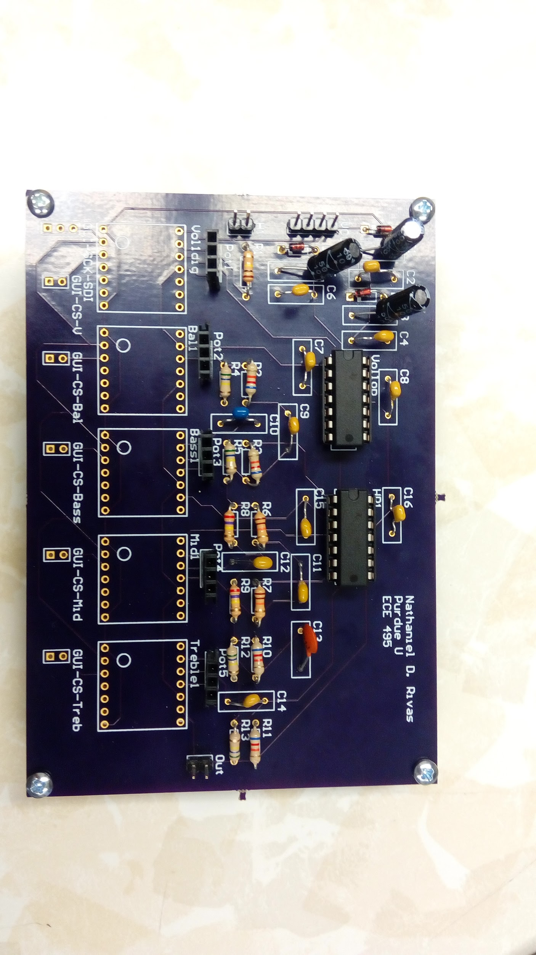

Figure 3.3.8.2: PCB Circuit (Testing in Progress)

### 3.3.9 Results (PCB)

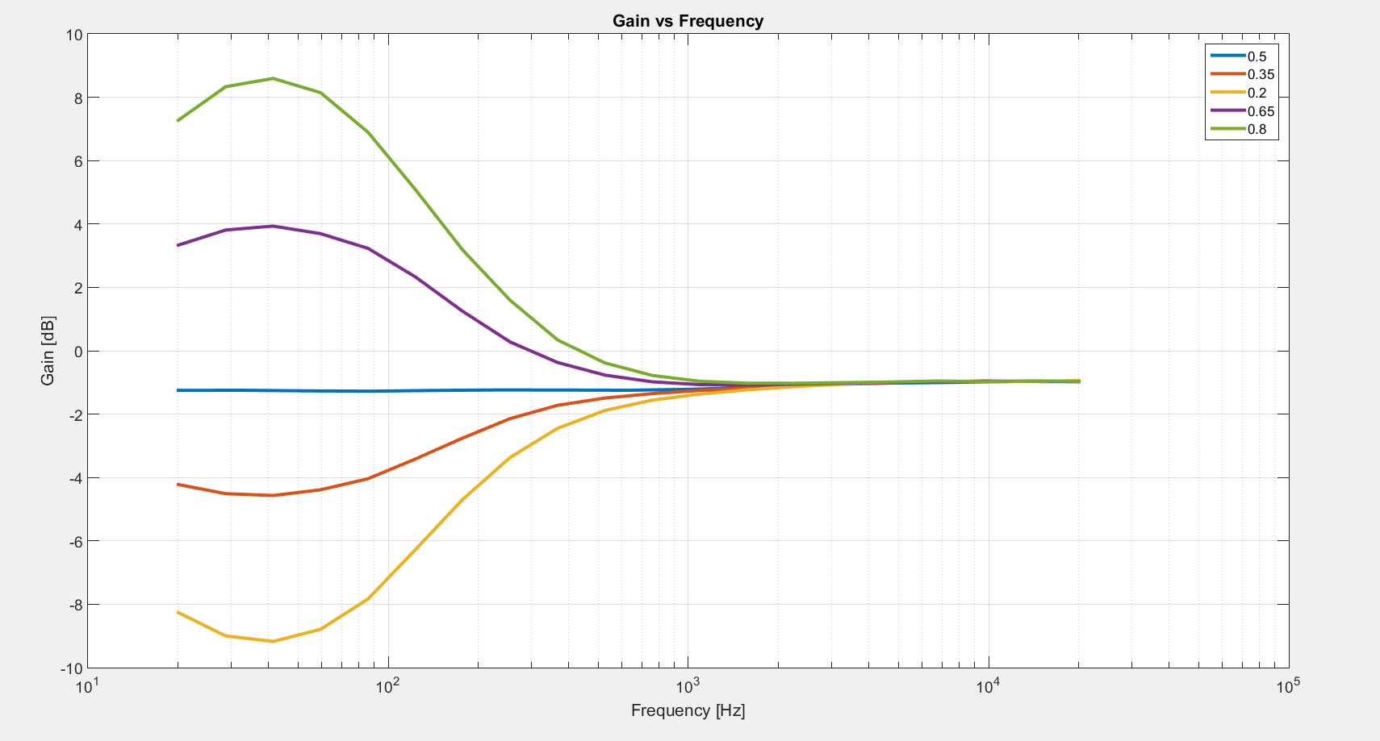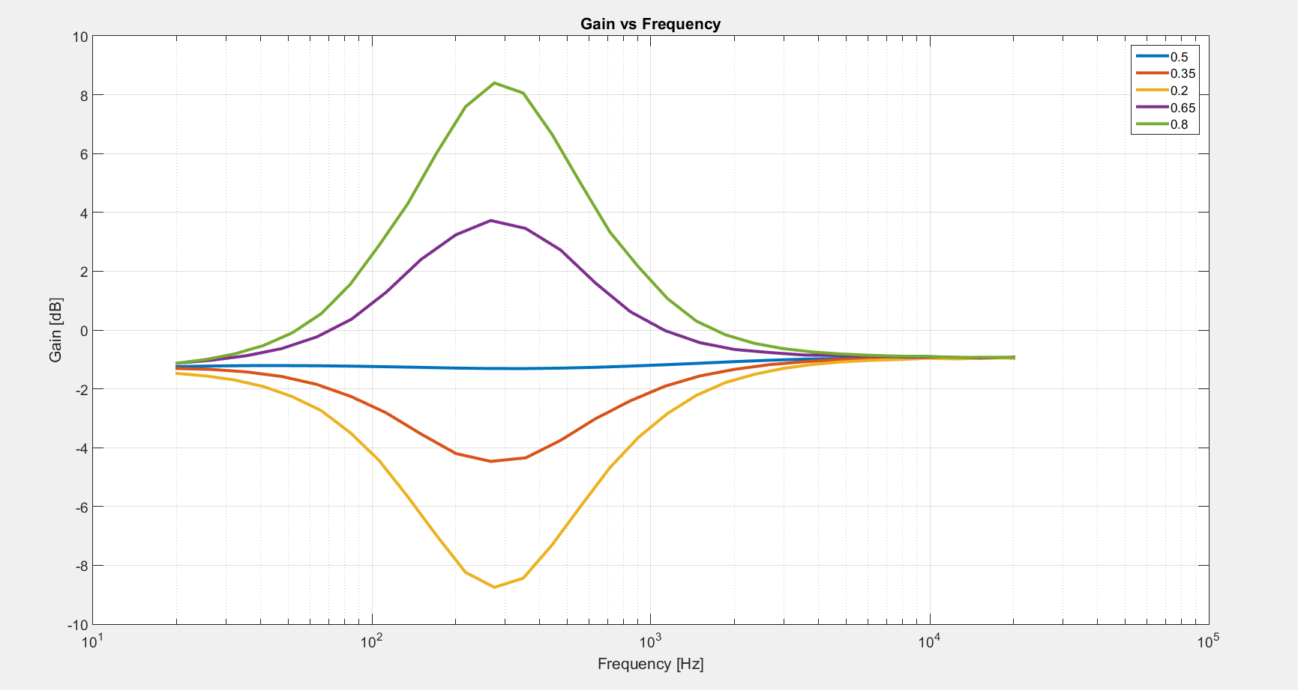

Figure 3.3.9.1: Gain vs Frequency for First Band Pass Figure 3.3.9.2: Gain vs Freq. for second Band Pass

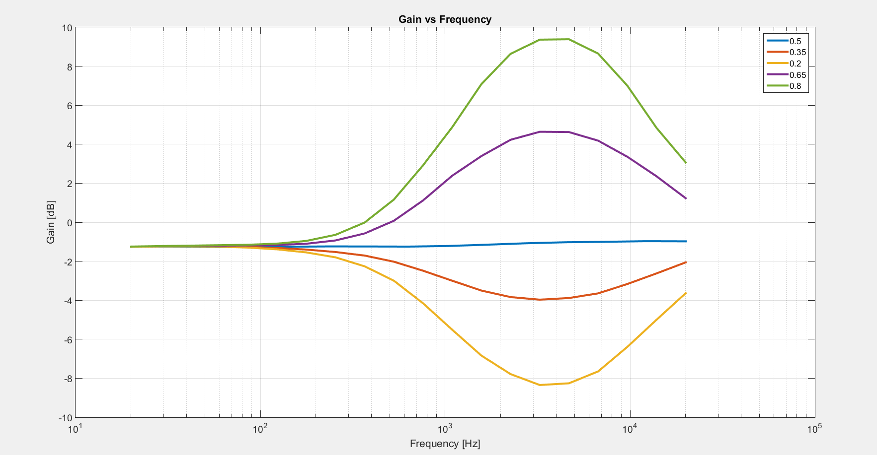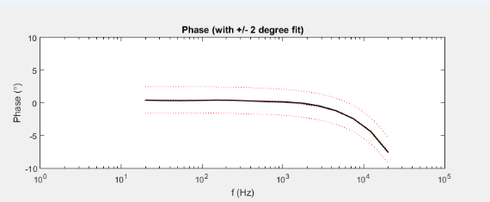

Figure 3.3.9.3: Gain vs Freq. for Third Band Pass Figure 3.3.9.4: Phase vs Freq. at Flat Response

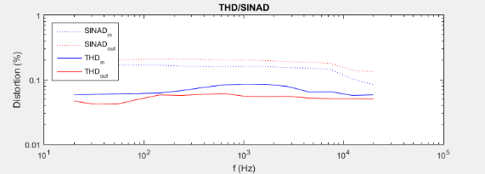

Figure 3.3.9.5: Total Harmonic Distortion

### 3.3.10 Testing Plan

Overall I want to show that the amplifier controls meets the requirements given by the customer.

Equipment that will be used:

1. Power Supply: Agilent E3631A
2. Oscilloscope: Keysight MSO-X 3014T
3. Function/Arbitrary Waveform Generator: Agilent 33220A
4. Digital Multimeter (DMM): Agilent 34401A
5. Audio Analyzer: Rohde & Schwarz

Testing:

1. Linear/Flat Phase Response without the Reconstruction Filter and tone controls set to zero dB (±2°).
   1. Supply power to the circuit: Vcc set to +5VDC, Vee set to -5VDC, and Ground set to 0VDC.
   2. Using the Audio Analyzer: Use the frequency sweep function with range from 20-20kHz and obtain the phase response which should be within ±2°.
2. Flat Frequency Response (±2.5dB).
   1. If using digipot: set Bass, Mid, and treble to 50%. If analog potentiometer: Using the DMM, measure the potentiometers and set them so they are the same on both ends.
   2. Use the frequency sweep function with range from 20-20kHz of the audio analyzer and obtain the gain response which should be within ±2.5dB.
3. Ability to control Volume and Balance from 0-100%.
   1. Supply Power to the circuit: Vcc set to +5VDC, Vee set to -5VDC, and Ground set to 0VDC.
   2. Input from the Function Generator: Sine wave with Amplitude at 1V pk-pk, Offset to 0V and a sweep from 20-20kHz.
   3. Oscilloscope should measure from the output of the volume and the output from the Balance.
   4. By adjusting the potentiometer for both the Volume and Balance from 0-100%, we can see that they work properly by giving an output in the range of 0-1V pk-pk.
4. Able to control the Bass, Mid and Treble with a minimum of ±6dB.
   1. Supply Power to the circuit: Vcc set to +5VDC, Vee set to -5VDC, and Ground set to 0VDC.
   2. Use the frequency sweep function with range from 20-20kHz of the audio analyzer.
   3. When the potentiometers are adjusted between 0-100% you should obtain a minimum of ±6dB. When adjusted, these should be within 20~200Hz, 200~1000Hz, and 1k~20kHz for Bass, Mid, and Treble respectively.

## 3.4 Power Amplifier

### 3.4.1 Subsystem Requirements

The basic functioning of the power amplifier system can be understood using the block diagram (Section 3.4.4). The differential amplifier helps reduce total harmonic distortions and serves as a negative feedback system. The gain stage is a class A amplifier which amplifies the voltage for the system. Class AB amplifier is used as the buffer stage which helps the system drive low impedance loads. The simulation (Section 3.4.7) and the oscilloscope (Section 3.1.8) results provide evidence that our design meets the customer specifications.

### 3.4.2 Electrical / Audio Specifications, all from 20Hz to 20kHz with 16-600Ω load:Image result for tick mark

* Support headphone impedances 16Ω - 600Ω.
* Output impedance < 2Ω.

Note: The output impedance is not yet been calculated due to some difficulties faced while using the method of Thevenin equivalent. 

* Flat frequency response (±2.5dB).
* Linear/flat phase response without the reconstruction filter and tone controls set to zero dB (±2°).

Note: The phase response exceeds the specifications for lower frequency values but falls under the specifications for the frequency range of 100 Hz – 20 kHz.

* Distortion < 1% THD into 150Ω at 1Vrms.
* Power amplifier must have as slew of >3V/µs using a 10kHz square wave near full output at 600Ω.
* Must not produce a DC offset >20mV during operation.

### 3.4.3 Power Calculations

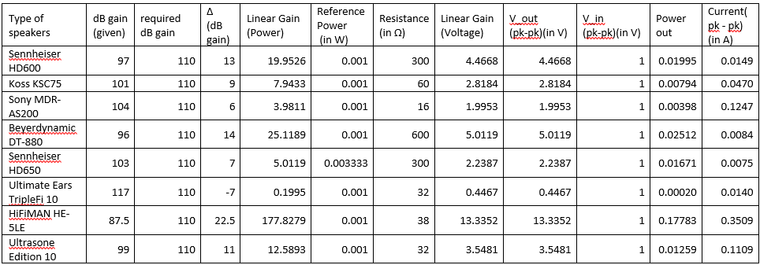

Table 3.4.3.1: Table showing various power and voltage calculations

### 3.4.4 Subsystem Block Diagram

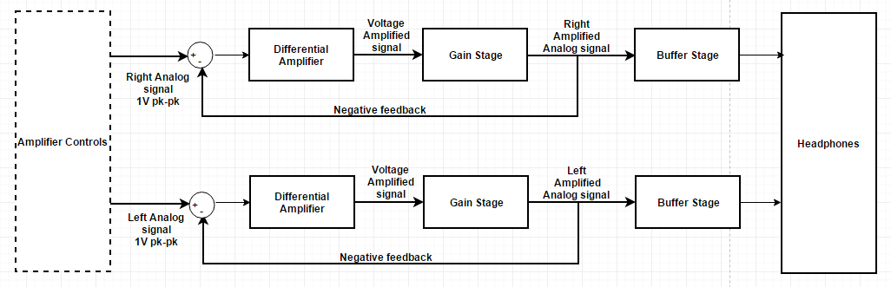

### 3.4.5 Design/ Schematic

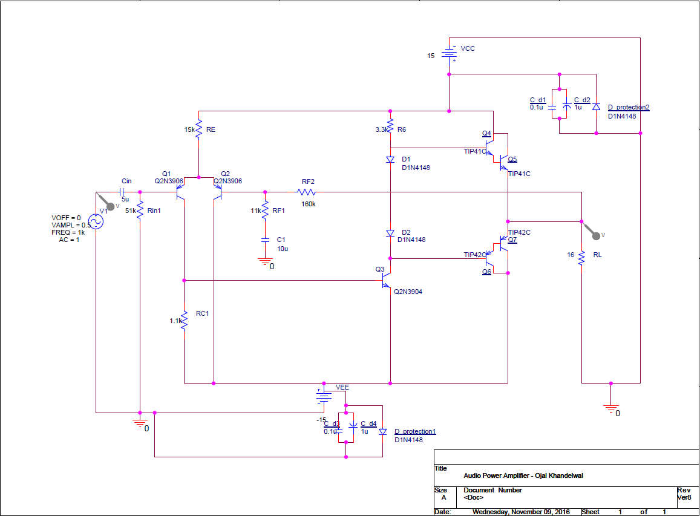

Figure 3.4.5.1: Schematic for Power Amplifier subsystem (one channel)

### 3.4.6 PSPICE Simulation Results

**Voltage Amplification**

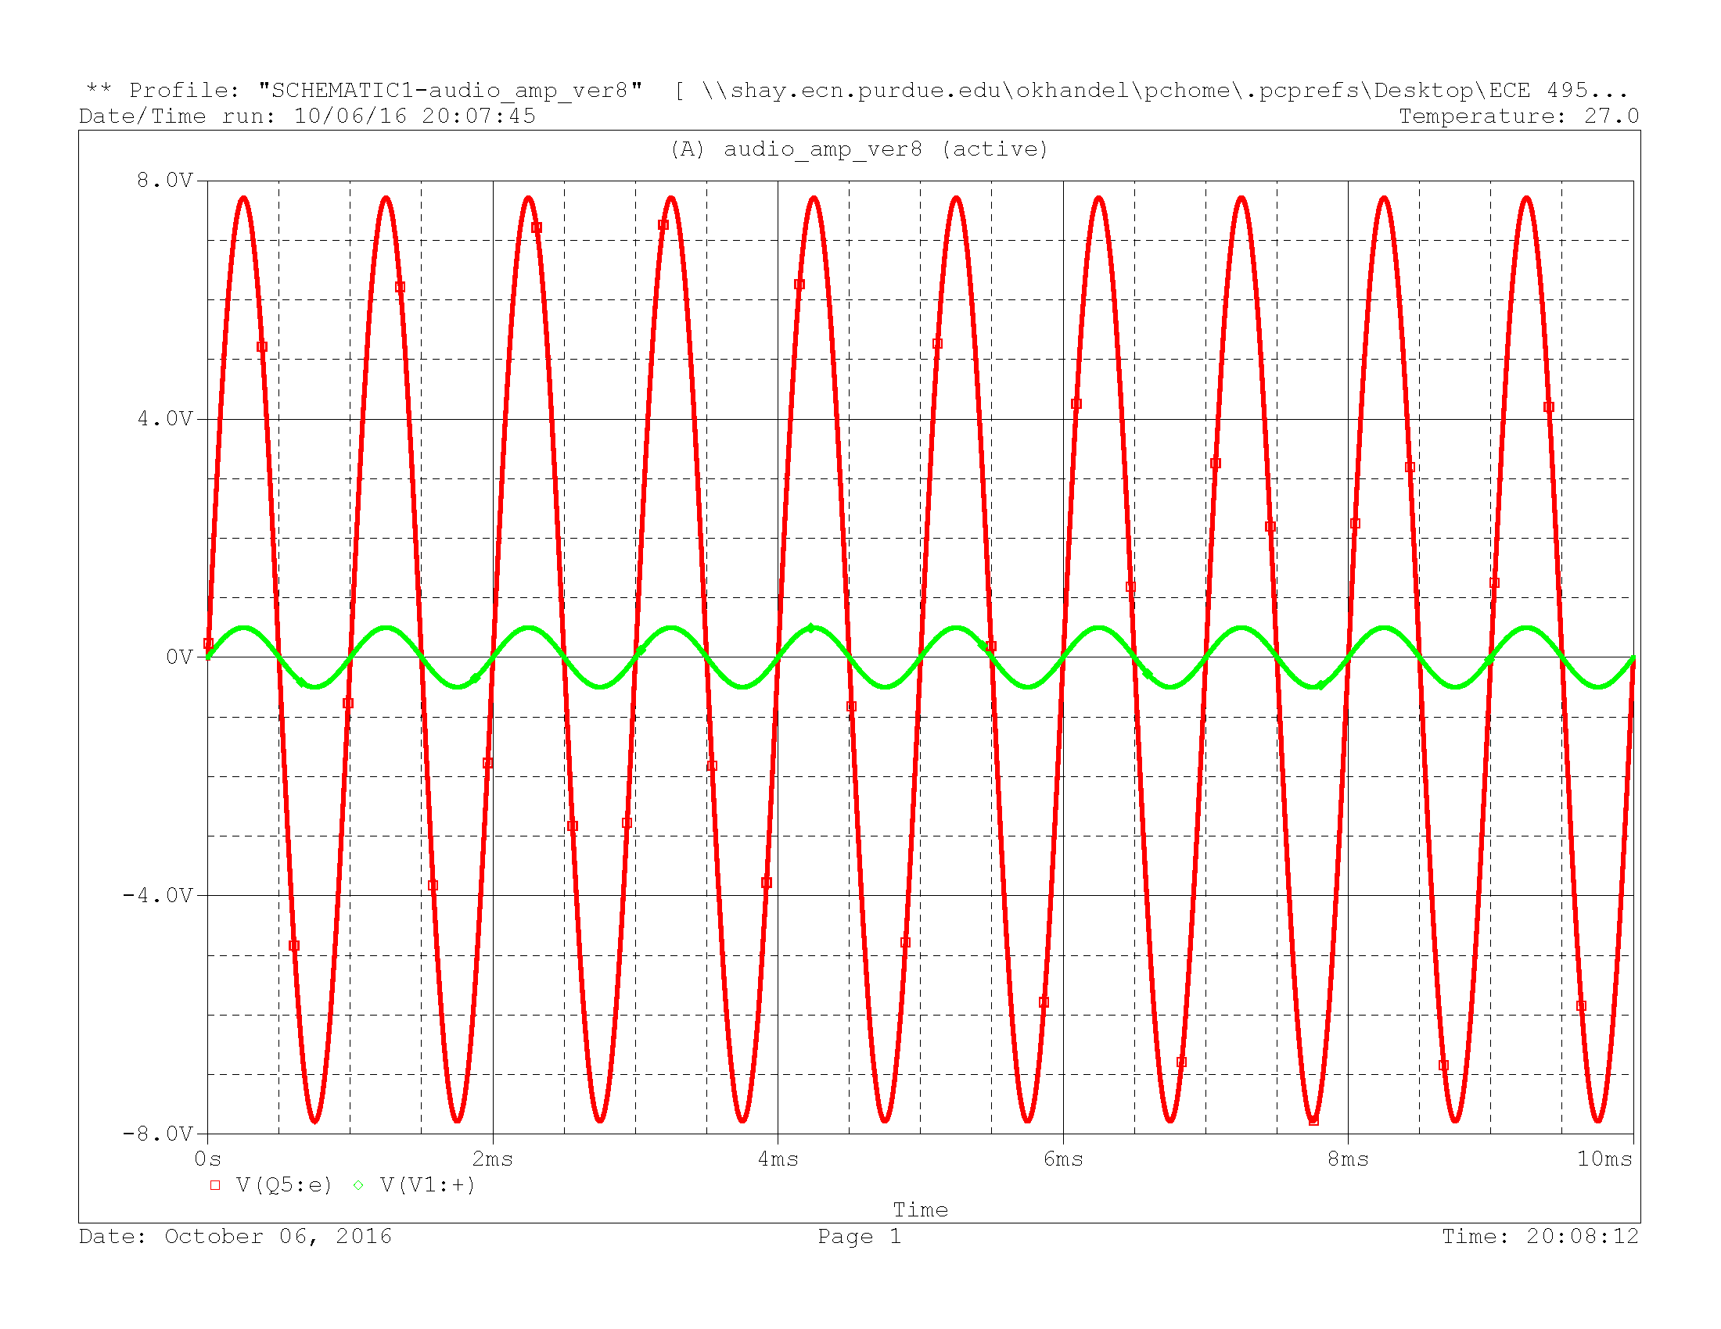

Figure 3.4.6.1: Voltage Amplification Plot (16 Ω)

Vin (pk-pk) = 1 V

Vout (pk-pk) = 15.5 V

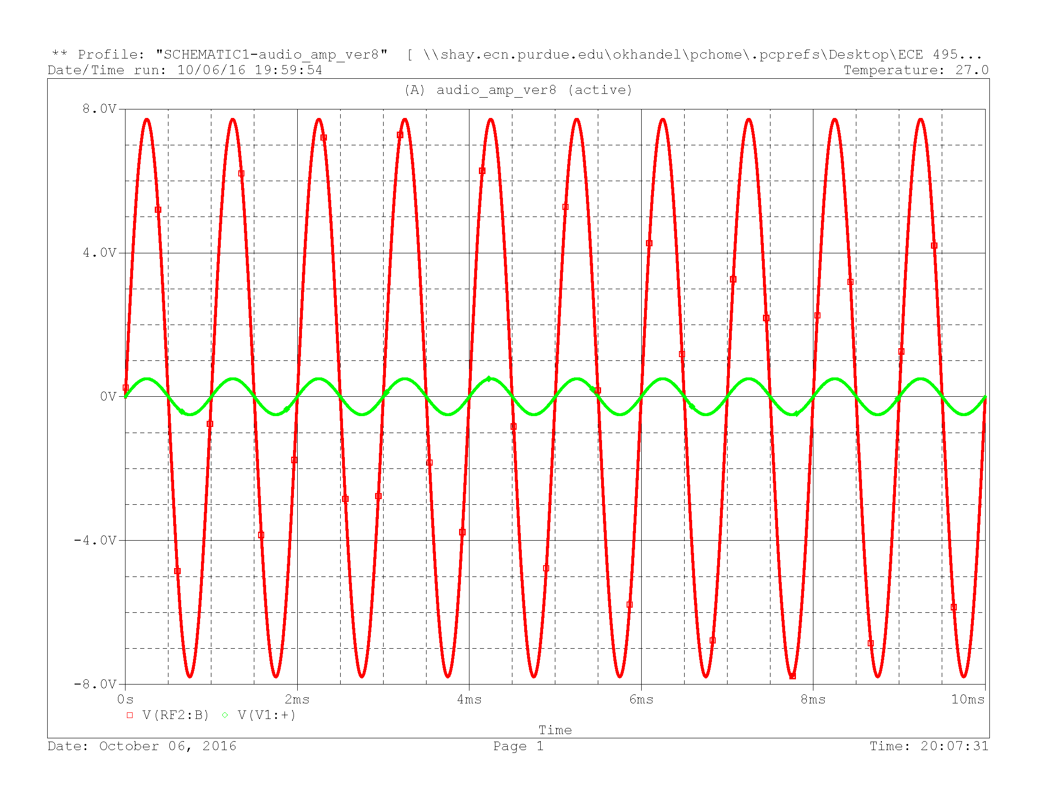

Figure 3.4.6.2: Voltage Amplification Plot (600 Ω)

Vin (pk-pk) = 1 V

Vout (pk-pk) = 15.5 V

**Gain Response**

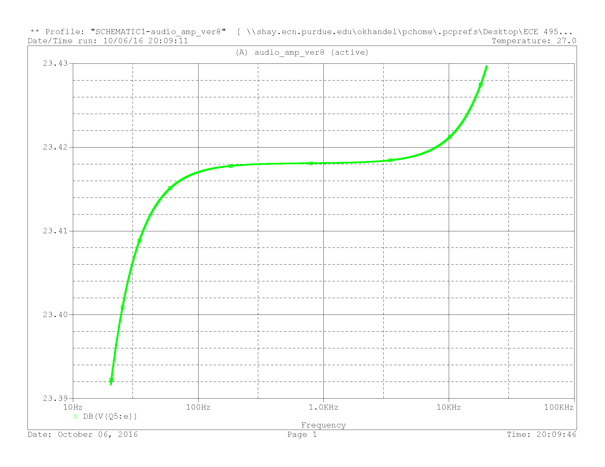

Figure 3.4.6.3: Gain Response (16 Ω)

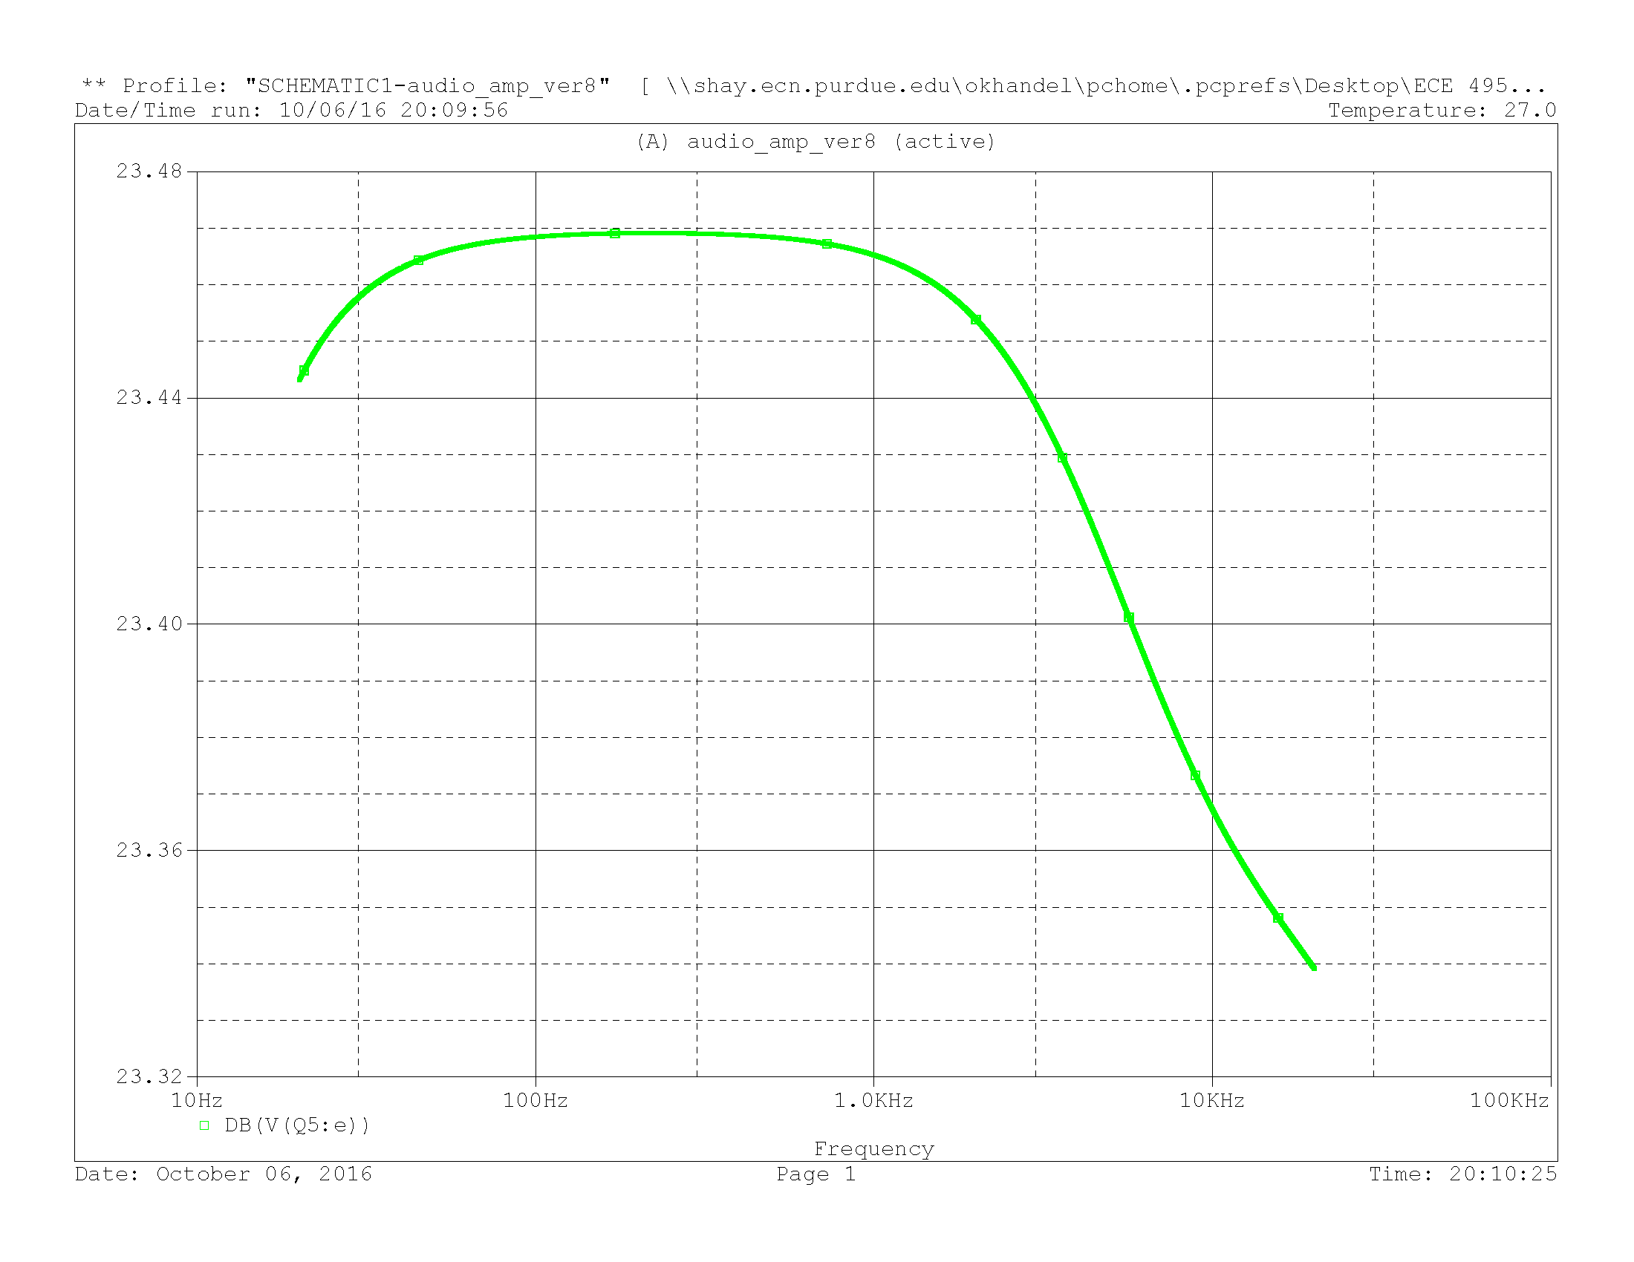

Figure 3.4.6.4: Gain Response (600 Ω)

Note: The gain response as seen from the above plot is a steady curve which satisfies our requirements.

**Phase Response**

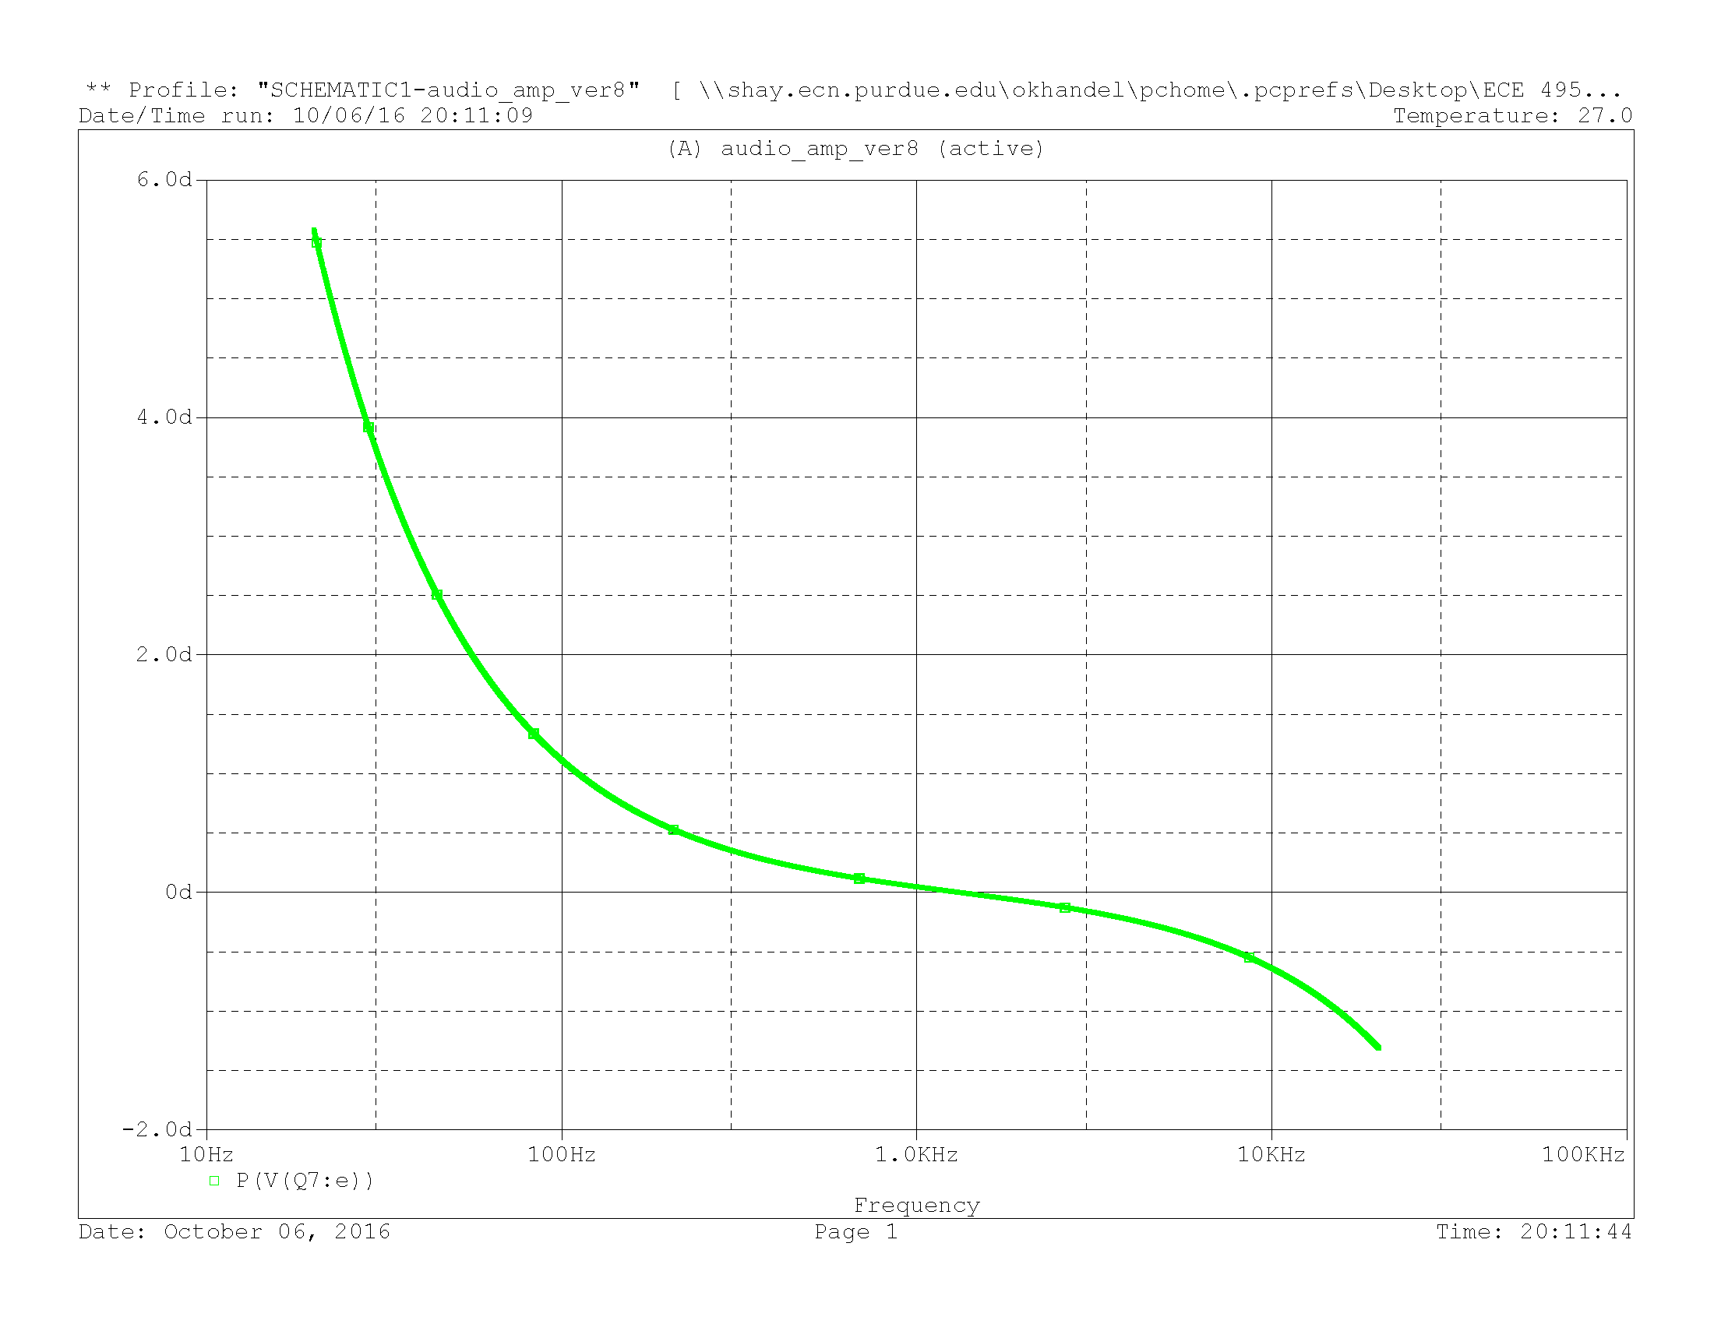

Figure 3.4.6.5: Phase Response (16 Ω)

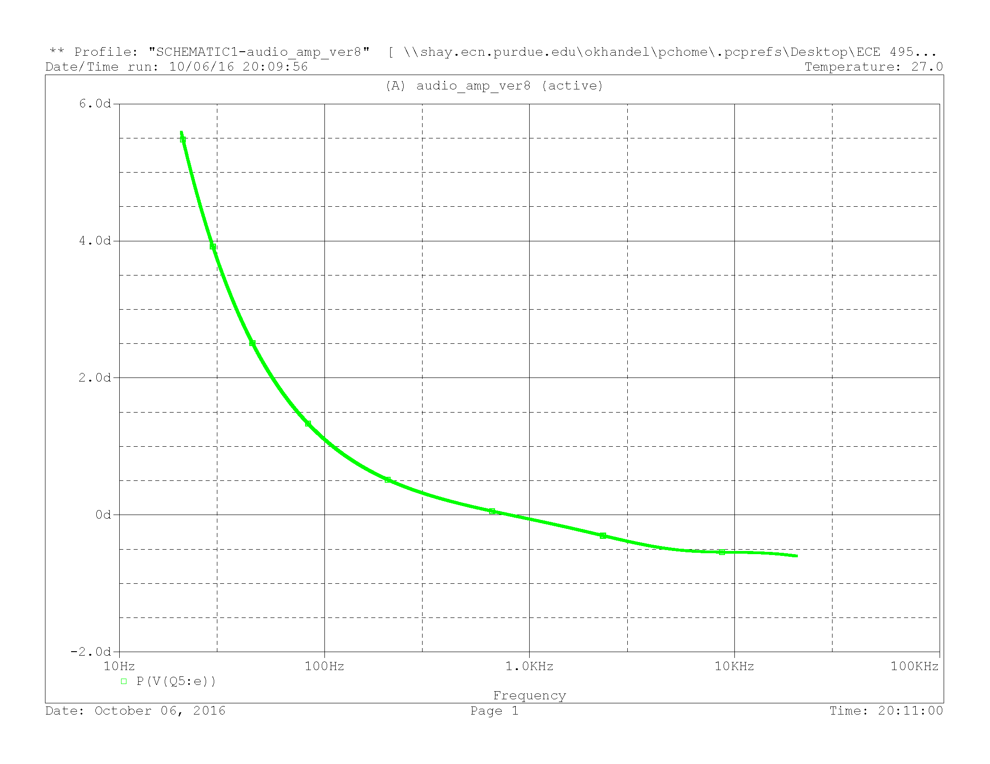

Figure 3.4.6.6: Phase Response (600 Ω)

Note: The phase response exceeds the specifications for lower frequency values but falls under the specifications for the frequency range of 100 Hz – 20 kHz.

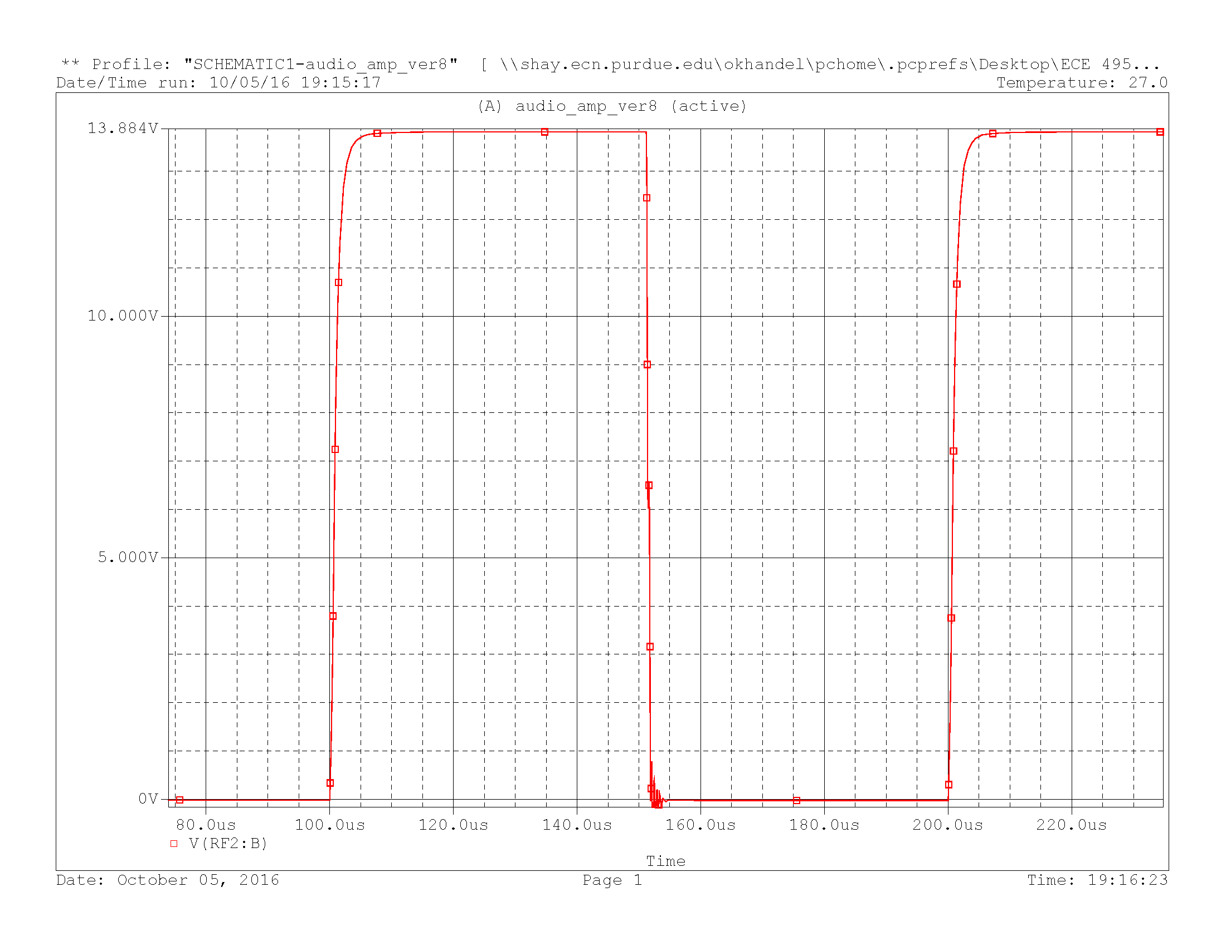

Figure 3.4.6.7: Signal response to square wave input (1Vpp and 1kHz)

**Slew rate** (slope of the rising edge of the output) = 6.5135 V/µs

The above slew rate fulfils the specification given by the customer i.e. slew rate > 3V/µs.

**Total Harmonic Distortion**

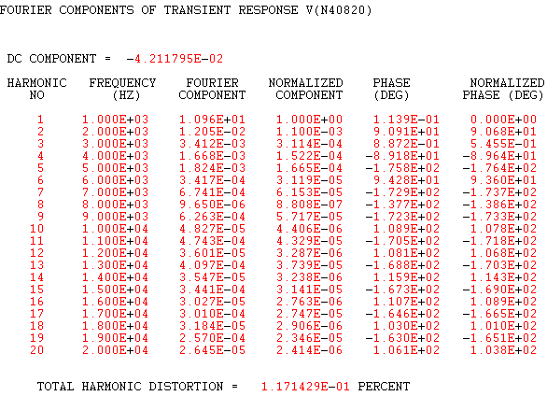

Note: The %THD falls under the specified range i.e. less than 1%.

**Power Dissipation**

At 16Ω:

At 600Ω:

**DC – Offset**

At 16Ω: -9.597 mV

At 600Ω: -10.09 mV

### 3.4.7 Prototype

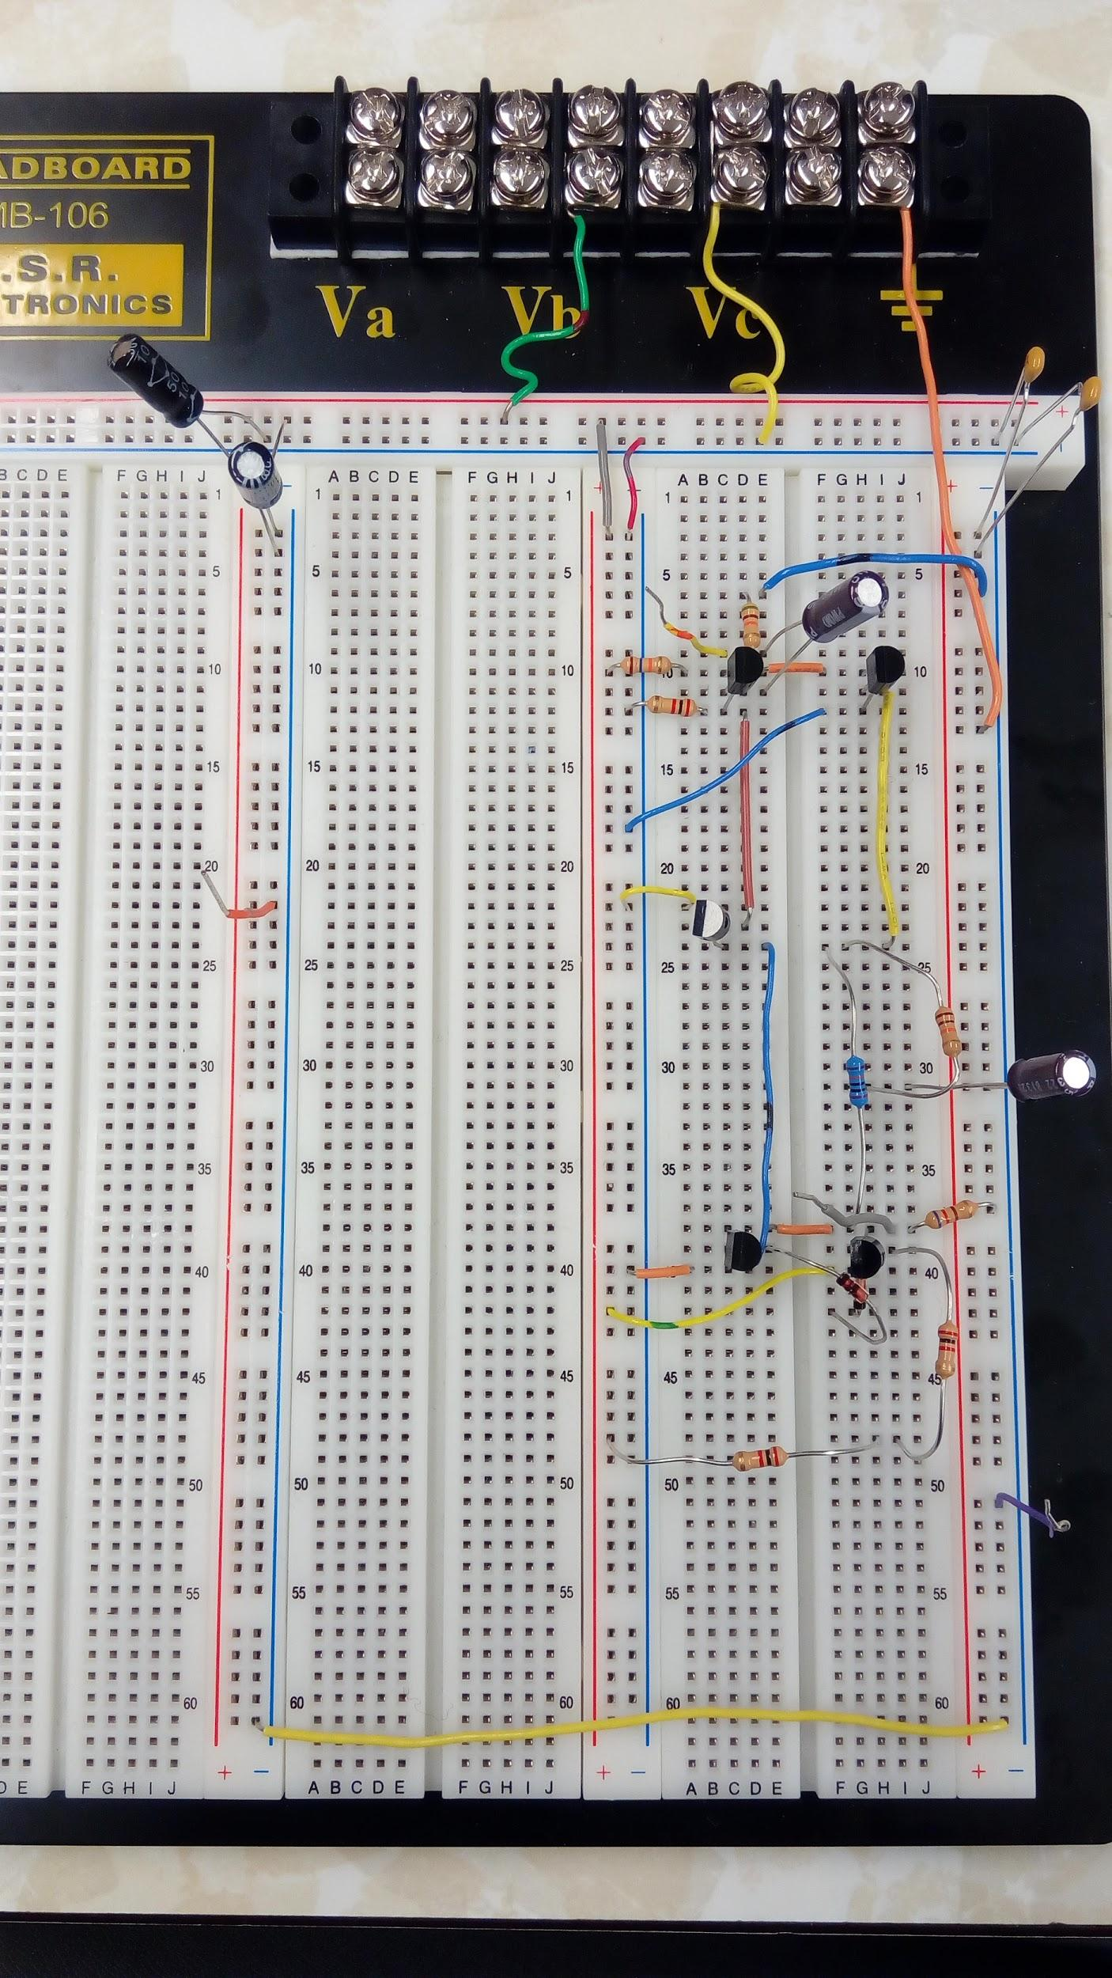

Figure 3.4.7.1: Prototype (Circuit on breadboard) (one channel)

### 15388810_10208065588893203_161660371_o.jpg

Figure 3.4.7.2: Prototype (PCB Desing) (one channel)



### Figure 3.4.7.3: Prototype (Solder Board) (one channel)

### 

### 

### 

### 

### 3.4.8 Oscilloscope Results

**Voltage Amplification**

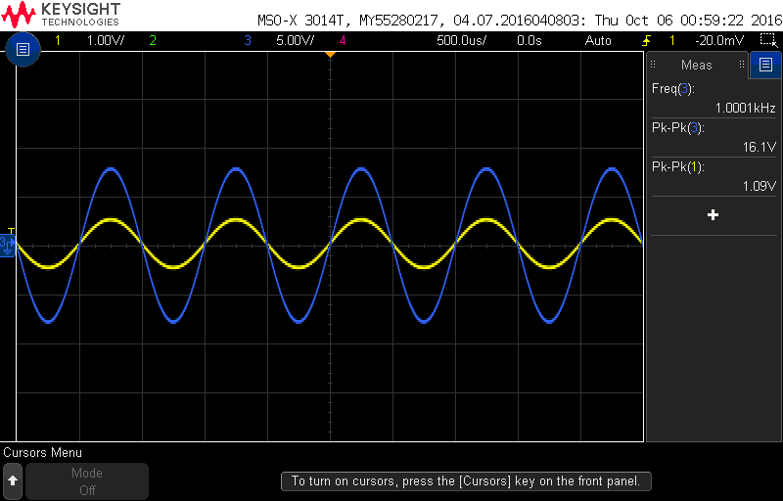

Figure 3.4.8.1: Voltage Amplification Plot (at RL = 600Ω)

Vin (pk-pk) = 1.09 V ; Vout (pk-pk) = 16.1 V

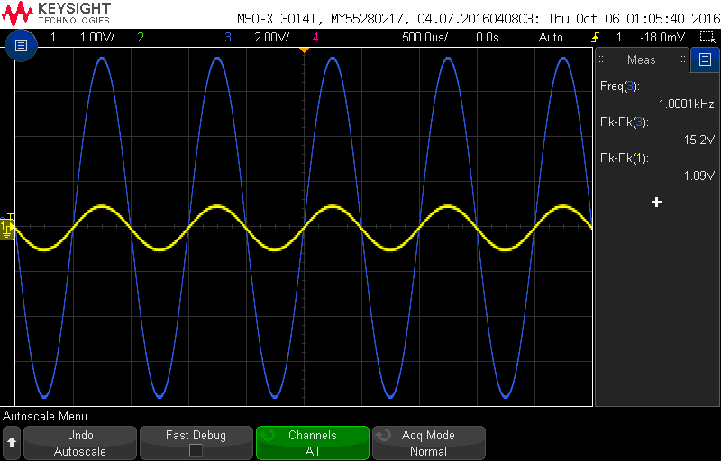

Figure 3.4.8.2: Voltage Amplification Plot (at RL = 16Ω)

Vin (pk-pk) = 1.09 V ; Vout (pk-pk) = 15.2 V

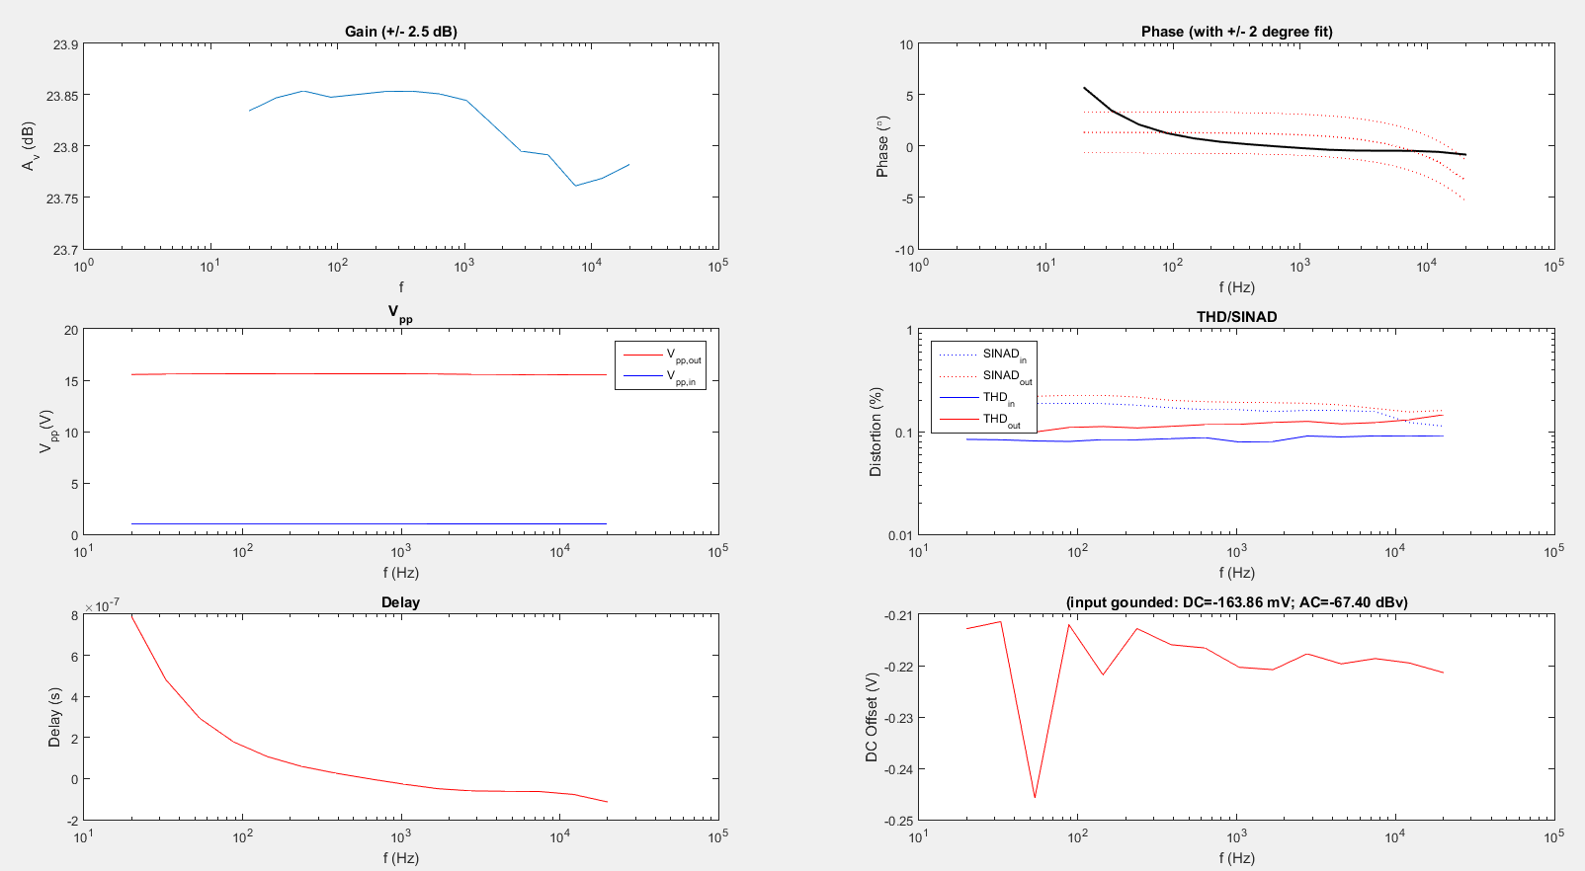

Figure 3.4.8.3: Plots obtained from Nathan’s Code (at RL = 600Ω)

The gain response as seen from the above plot is a steady curve and has a high value which satisfies our requirements.The phase response exceeds the specifications for lower frequency values. Tweaking the values of the capacitors will help get the phase response within the specification limits.

% THD = 0.1% (approximately) (from the matlab plot)

This also satisfies the specifications which require the %THD < 1%.

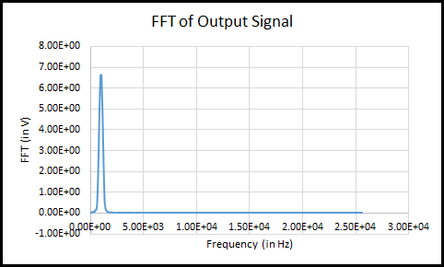 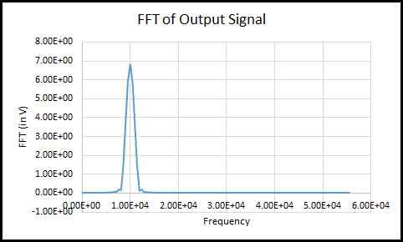

Figure 3.4.8.4: FFT plot to calculate the THD for the output signal (at 1kHz and 10 kHz)

% THD = 0.115 % (for 1 kHz)

% THD = 0.521 % (for 10 kHz)

This also satisfies the specifications which require the %THD < 1%.

|  |  |
| --- | --- |
| Frequency | DC Offset |
| 20 Hz | 0.776 mV |
| 100 Hz | 2.5 mV |
| 1 kHz | 6.2 mV |
| 10 kHz | -2.2 mV |
| 20 kHz | -17.735 mV |

Table 3.4.8.1: DC offset value at various frequencies

The above table was measured at RL = 600Ω. The above results (Table 3.4.5.1) were taken with the help of Digital Multimeter, which reflected that the DC offset falls within the specification (DC offset < 20 mV) for the given frequency range i.e. 20 Hz – 20 kHz.

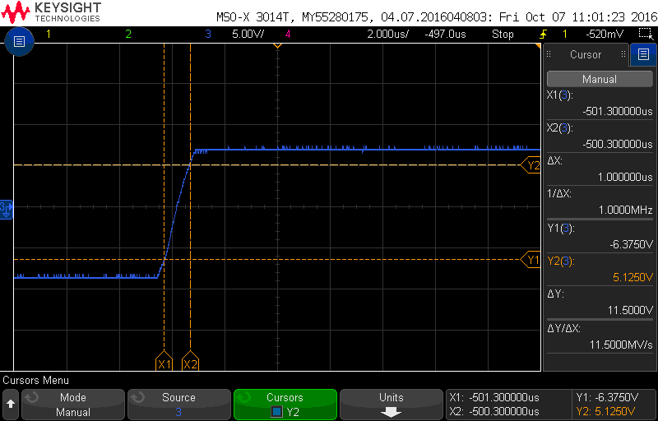

Figure 3.4.8.5: Signal response to a square wave input (1Vpp and 1kHz)

**Slew rate** (slope of the rising edge of the output) = 11.5 V/µs

The above slew rate fulfils the specification given by the customer i.e. slew rate > 3V/µs.

### 3.4.9 PCB Schematic: Altium Designer

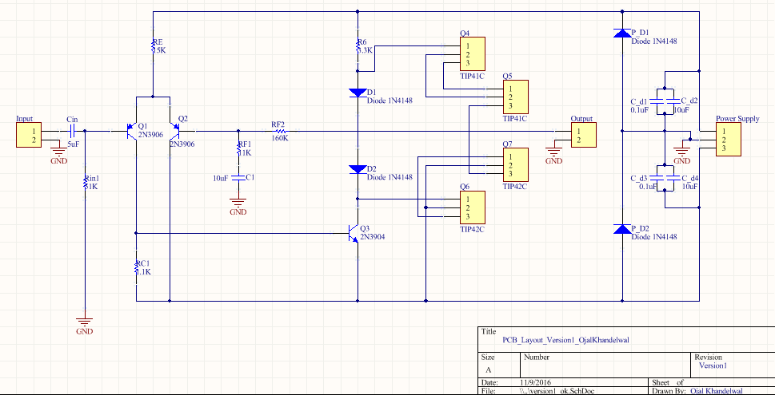Figure 3.4.9.1: Schematic for Power Amplifier subsystem (one channel)

### 3.4.10 PCB Layout

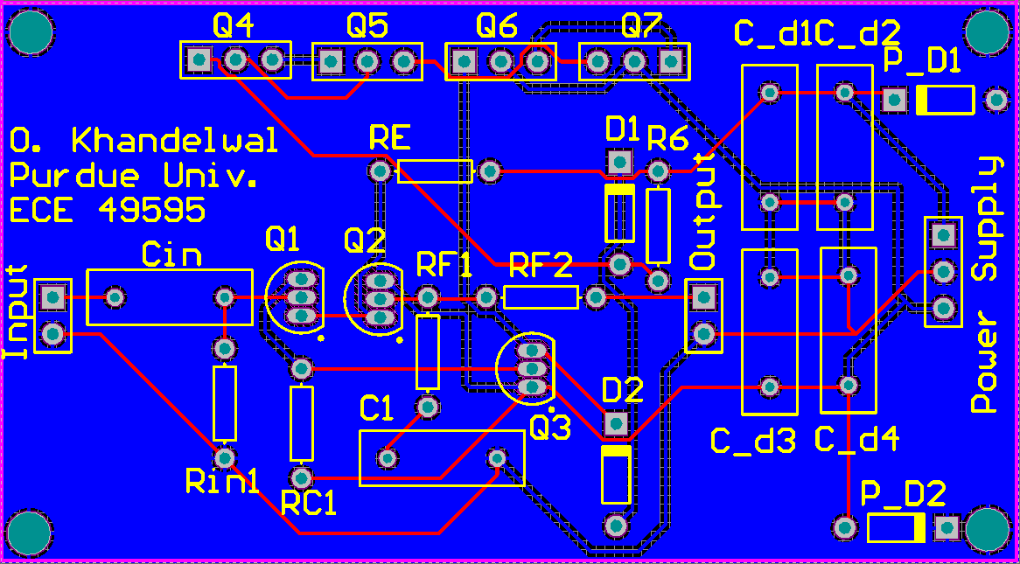

Figure 3.4.10.1: PCB Layout (Mechanical Layer, one channel)

### 3.4.11 PCB Results

**Voltage Amplification**

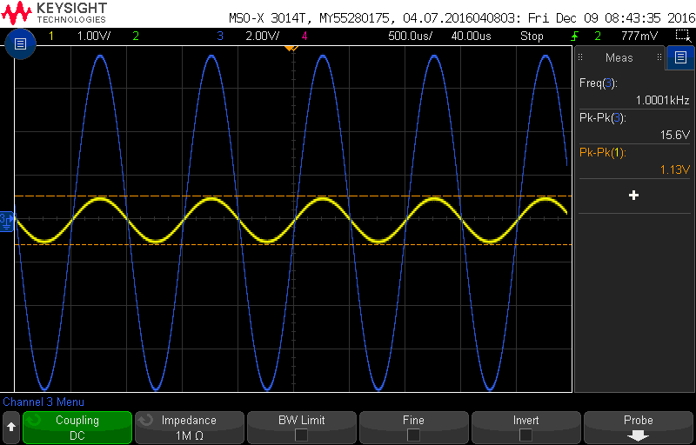

Figure 3.4.10.1: Voltage Amplification Plot (at RL = 300Ω)

Vin (pk-pk) = 1.13 V ; Vout (pk-pk) = 15.6 V

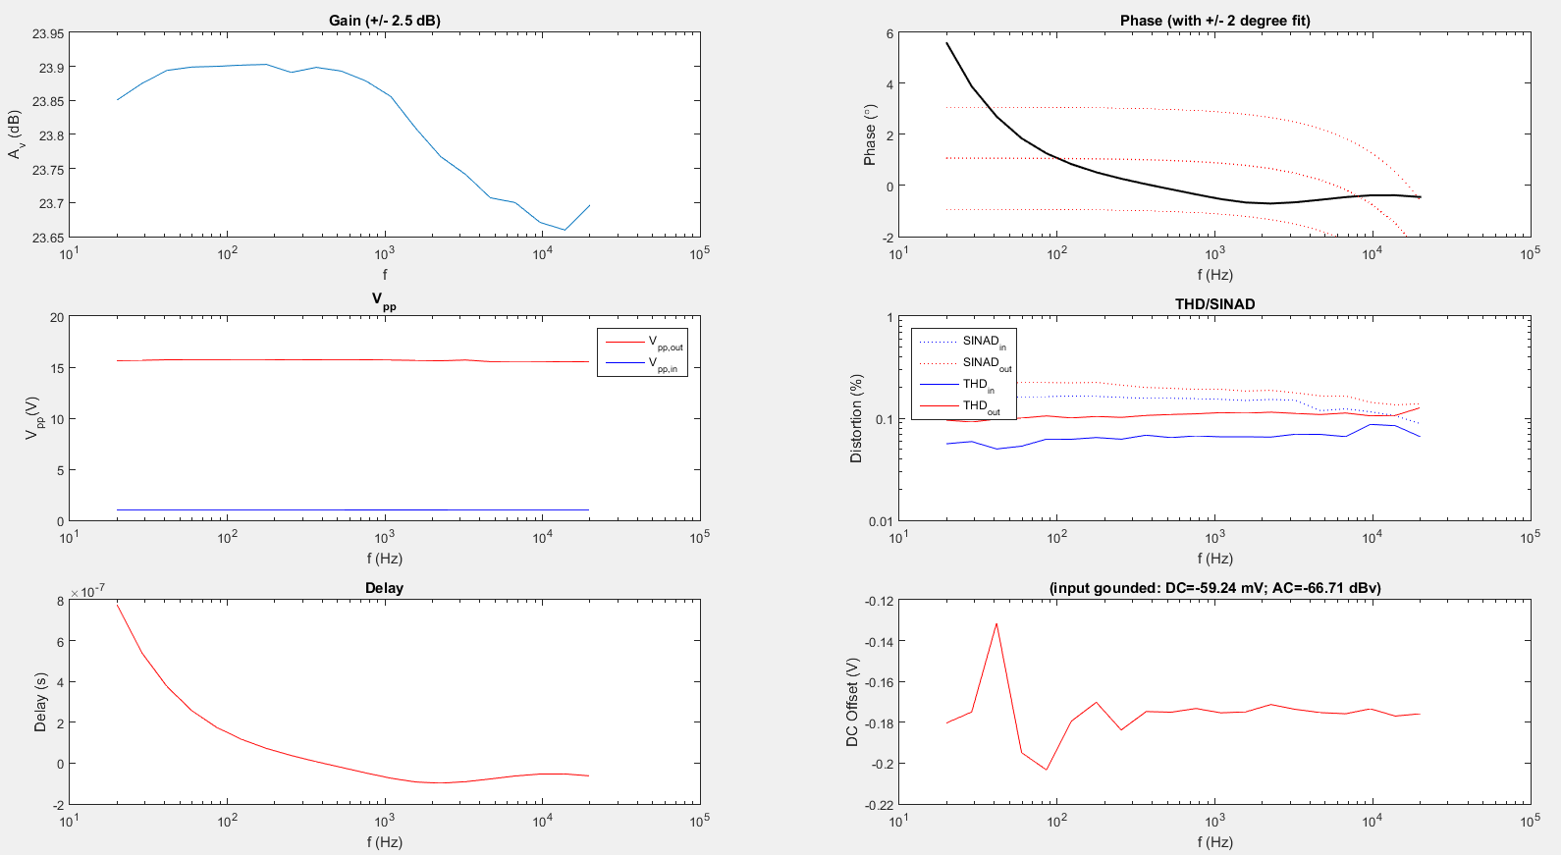

Figure 3.4.10.2: Plots obtained from Nathan’s Code (at RL = 300Ω)

The gain response as seen from the above plot is a steady curve and has a high value which satisfies our requirements.The phase response exceeds the specifications for lower frequency values.

% THD = 0.1% (approximately) (from the matlab plot)

This also satisfies the specifications which require the %THD < 1%.

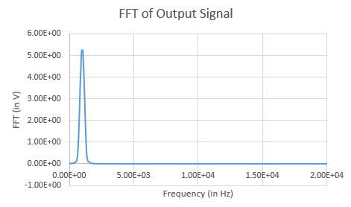

Figure 3.4.10.3: FFT plot to calculate the THD for the output signal (at 1kHz and Rl = 300 Ω)

% THD = 0.213 % (for 1 kHz)

This also satisfies the specifications which require the %THD < 1%.

|  |  |
| --- | --- |
| Frequency | DC Offset |
| 20 Hz | 0.4V |
| 100 Hz | 5.33 mV |
| 1 kHz | 6.05 mV |
| 10 kHz | -0.1 mV |
| 20 kHz | -12.25 mV |

Table 3.4.10.1: DC offset value at various frequencies

The above table was measured at RL = 300Ω. The above results (Table 3.4.5.1) were taken with the help of Digital Multimeter, which reflected that the DC offset falls within the specification (DC offset < 20 mV) for the given frequency range i.e. 100 Hz – 20 kHz.The DC offset at a frequency of 20Hz is higher than the given value.

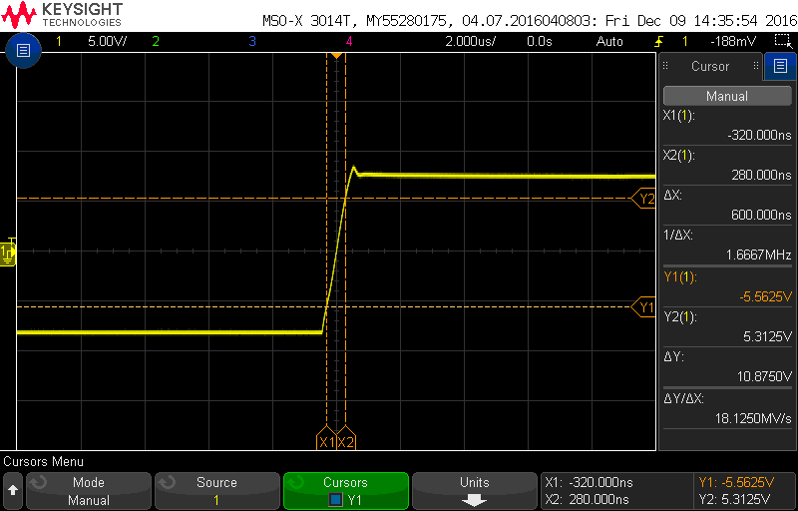

Figure 3.4.8.5: Signal response to a square wave input (1Vpp and 1kHz)

**Slew rate** (slope of the rising edge of the output) = 21.75 V/µs

The above slew rate fulfils the specification given by the customer i.e. slew rate > 3V/µs.

### 3.4.12 Solder Board Results

**Voltage Amplification**



Figure 3.4.12.1: Voltage Amplification Plot (at RL = 300Ω)

Vin (pk-pk) = 1.13 V ; Vout (pk-pk) = 15.6 V



Figure 3.4.12.2: Plots obtained from Nathan’s Code (at RL = 300Ω)

The gain response as seen from the above plot is a steady curve and has a high value which satisfies our requirements.The phase response exceeds the specifications for lower frequency values.

% THD = 0.1% (approximately) (from the matlab plot)

This also satisfies the specifications which require the %THD < 1%.

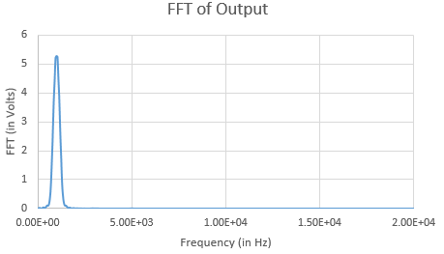

Figure 3.4.12.3: FFT plot to calculate the THD for the output signal (at 1kHz and Rl = 300 Ω)

% THD = 0.3223 % (for 1 kHz)

This also satisfies the specifications which require the %THD < 1%.

|  |  |
| --- | --- |
| Frequency | DC Offset |
| 20 Hz | 0.6V |
| 100 Hz | 4.7 mV |
| 1 kHz | 7.4 mV |
| 10 kHz | 3.6 mV |
| 20 kHz | -2.2 mV |

Table 3.4.12.1: DC offset value at various frequencies

The above table was measured at RL = 300Ω. The above results (Table 3.4.5.1) were taken with the help of Digital Multimeter, which reflected that the DC offset falls within the specification (DC offset < 20 mV) for the given frequency range i.e. 100 Hz – 20 kHz.The DC offset at a frequency of 20Hz is higher than the given value.

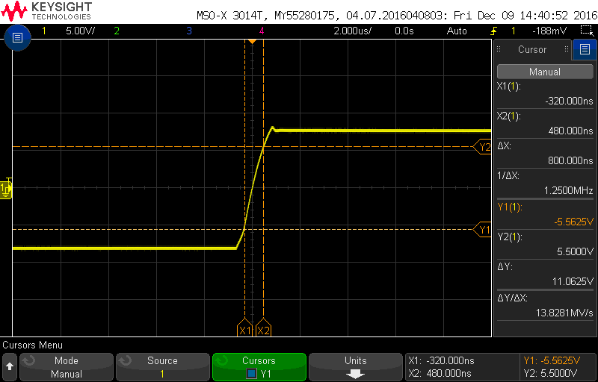

Figure 3.4.12.4: Signal response to a square wave input (1Vpp and 1kHz)

**Slew rate** (slope of the rising edge of the output) = 13.59 V/µs

The above slew rate fulfils the specification given by the customer i.e. slew rate > 3V/µs.

### 3.4.13 Testing Plan

**Objective:** To gain evidence that the power amplifier subsystem fulfills the specifications given by the customer.

For conducting the tests, the following set of equipment were used:

* Power Supply: Agilent E3631A
* Oscilloscope: Keysight MSO-X-3014T (100MHz, 5 GSa/s)
* Arbitrary waveform generator/ Function generator: Agilent 33220A
* Digital Multi Meter(DMM): Agilent 34410A
* Audio Analyzer: Rohde & Schwarz

1. **Support headphone impedances 16 Ω – 600 Ω.**

* Connect the various specified resistive loads (impedances of the given list of headphones) between the output node and ground. Attain values for the other specifications and check whether they fall under the given limits.

1. **Output impedance < 2 Ω.**

We will use the method of Thevenin equivalent to find the output impedance of the circuit.

* Supply power to the circuit using the Power Supply.

Vcc: +15 V

Vee: -15 V

Ground: 0 V

* Provide the input using the arbitrary waveform generator.

Type of signal: Sine wave

Amplitude: 1Vpk-pk

DC offset: 0V

Frequency: 1 kHz

* Measure the open circuit voltage (VOC) of the circuit, without any load resistance, using the oscilloscope. Use the measure feature and select “pk-pk” as measurement type.

Voc = V

* Measure the load voltage (VL) by connecting a load of value RL between the output terminal and the ground. Measure the load voltage using the oscilloscope. Use the measure feature and select “pk-pk” as measurement type.

VL = V

* Use the following formula to calculate the output impedance (ZO).

ZO = Ω

**Note:** This method has not been yet tested on the amplifier circuit design.

1. **Linear/flat phase response without the reconstruction filter and tone controls set to 0dB (±2°).**

* Supply power to the circuit using the Power Supply.

VCC: +15 V

VEE: -15 V

Ground: 0 V

* Provide the input using the function generator.

Type of signal: Sine wave

Amplitude: 1Vpk-pk

DC offset: 0V

Frequency: Any value between 20 Hz – 20 kHz (preferably 1 kHz)

**Method 1:**

* Use the measure feature on the oscilloscope plot, and select the measurement type as “Phase” to obtain the phase value at a certain frequency value.

**Method 2:**

* Use the frequency sweep function of the audio analyzer and obtain the phase response.

1. **Flat frequency response (±2dB)**

* Use the frequency sweep function of the audio analyzer and obtain the gain response.

1. **Distortion < 1% THD into 150 Ω at 1Vrms.**

* Supply power to the circuit using the Power Supply.

VCC: +15 V

VEE: -15 V

Ground: 0 V

* Provide the input using the function generator.

Type of signal: Sine wave

Amplitude: 1.414 Vpk-pk

DC offset: 0V

Frequency: Any value between 20 Hz – 20 kHz (preferably 1 kHz)

* Connect a load of value RL equal to 150 Ω between the output terminal and the ground.
* Click on the FFT button on the oscilloscope, to switch on the fast fourier transform mode.
* Set the value of the center frequency equal to half the value of the input frequency.
* Save the data in form of a csv file using the “Save/Recall” function on the oscilloscope.
* Plot the data obtained above using Microsoft excel and measure the % THD using the following formula.

% THD = $$\frac{\sum_{n=2}^{5}{}harmonics }{fundamental harmonic }$$

1. **Power amplifier must have a slew rate of > 3V/μs using a 10kHz square wave near full output at 600Ω.**

* Supply power to the circuit using the Power Supply.

VCC: +15 V

VEE: -15 V

Ground: 0 V

* Provide the input using the function generator.

Type of signal: Square wave

Amplitude: 1 Vpk-pk

DC offset: 0V

Frequency: 10 kHz

* Connect a load of value RL equal to 600 Ω between the output terminal and the ground.
* Connect the oscilloscope to view the output signal. It would look like a trapezoidal signal.
* Measure the slope of the rising edge of the output signal using cursors. The slew rate is equal to the slope.

1. **Must not produce a DC offset > 20 mV during operation.**

* Supply power to the circuit using the Power Supply.

VCC: +15 V

VEE: -15 V

Ground: 0 V

* Provide the input using the function generator.

Type of signal: Sine wave

Amplitude: 1.414 Vpk-pk

DC offset: 0V

Frequency: Values between 20 Hz – 20 kHz

* For different frequency values note the DC voltage value from the DMM and put them in a tabular form. These voltages are the DC offset values.

# 4. Integration of Sub-Systems

## 4.1 Digital to Analog Converter with Amplifier Controls

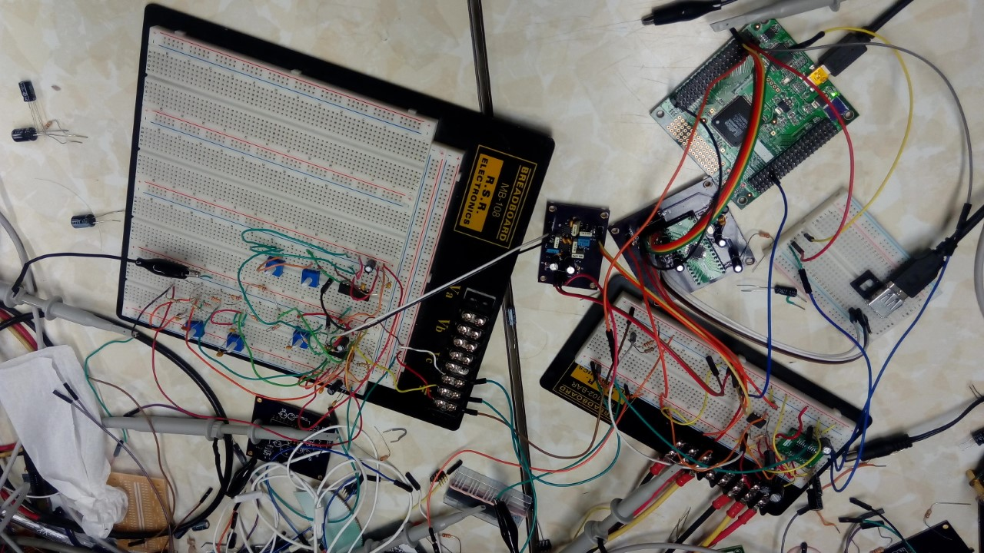

Figure 4.1.1: Integrated breadboard Circuits (D to A (left) and Amplifier Controls(right))

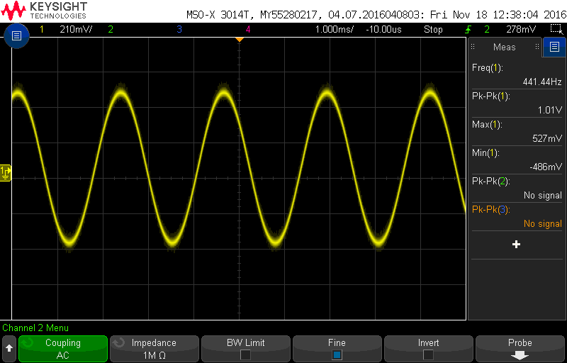

Figure 4.2.2: Voltage Amplification Oscilloscope Plot

## 4.2 VU/GUI with Amplifier Controls

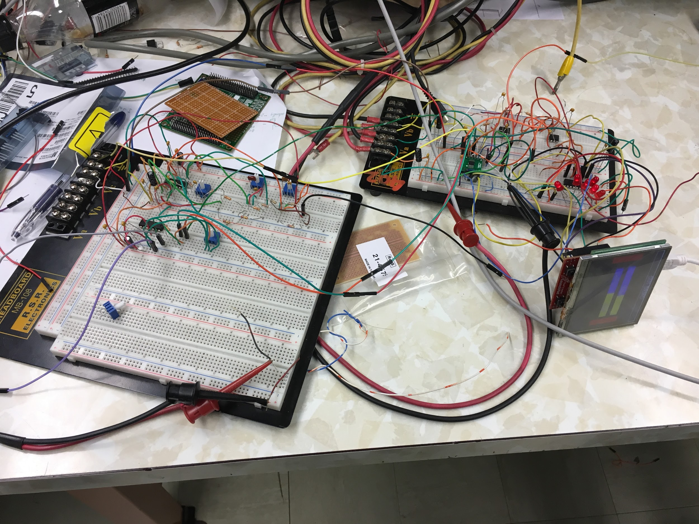

Figure 4.2.1: Integrated breadboard Circuits (VU/GUI (right) and Amplifier Controls(left))

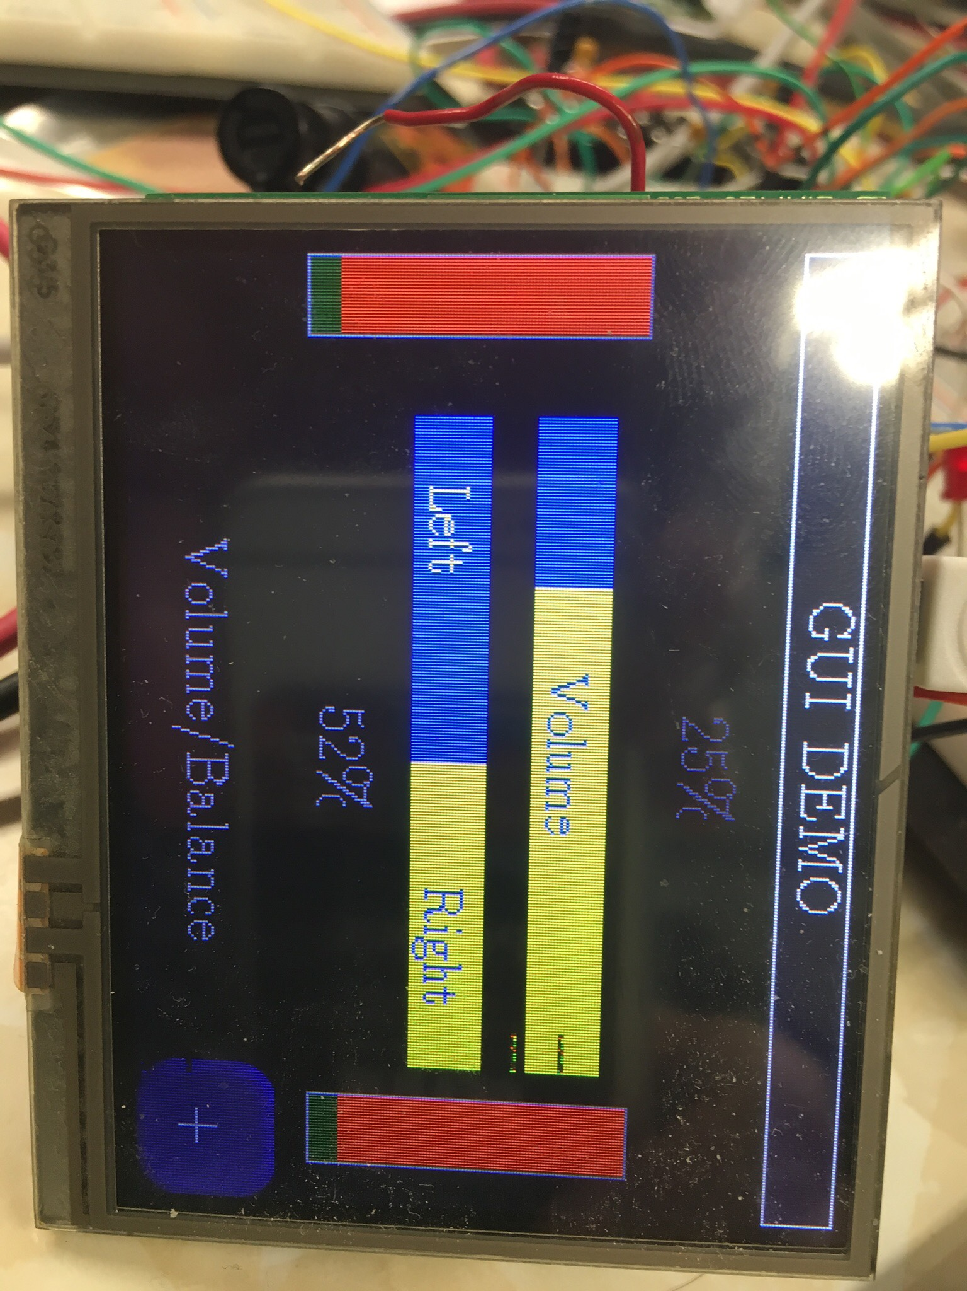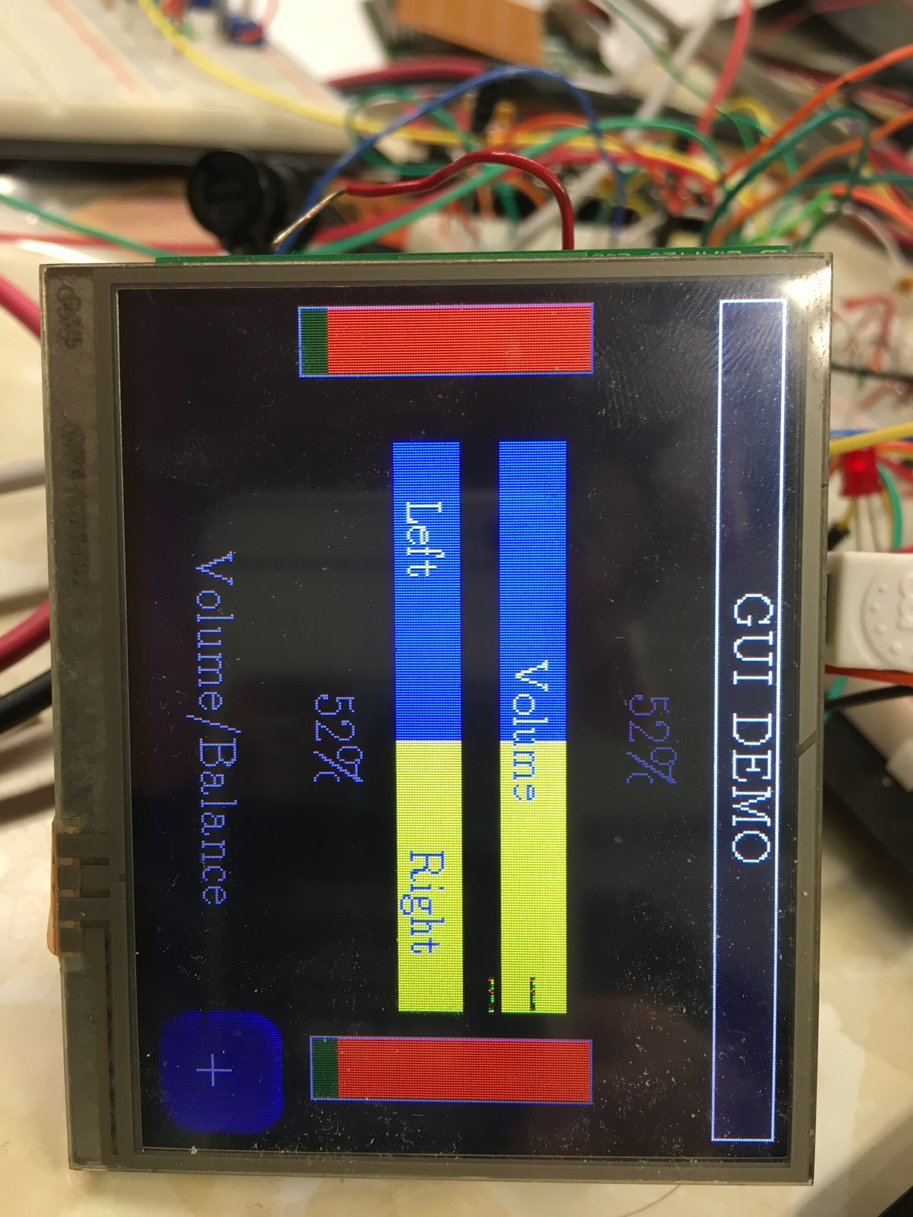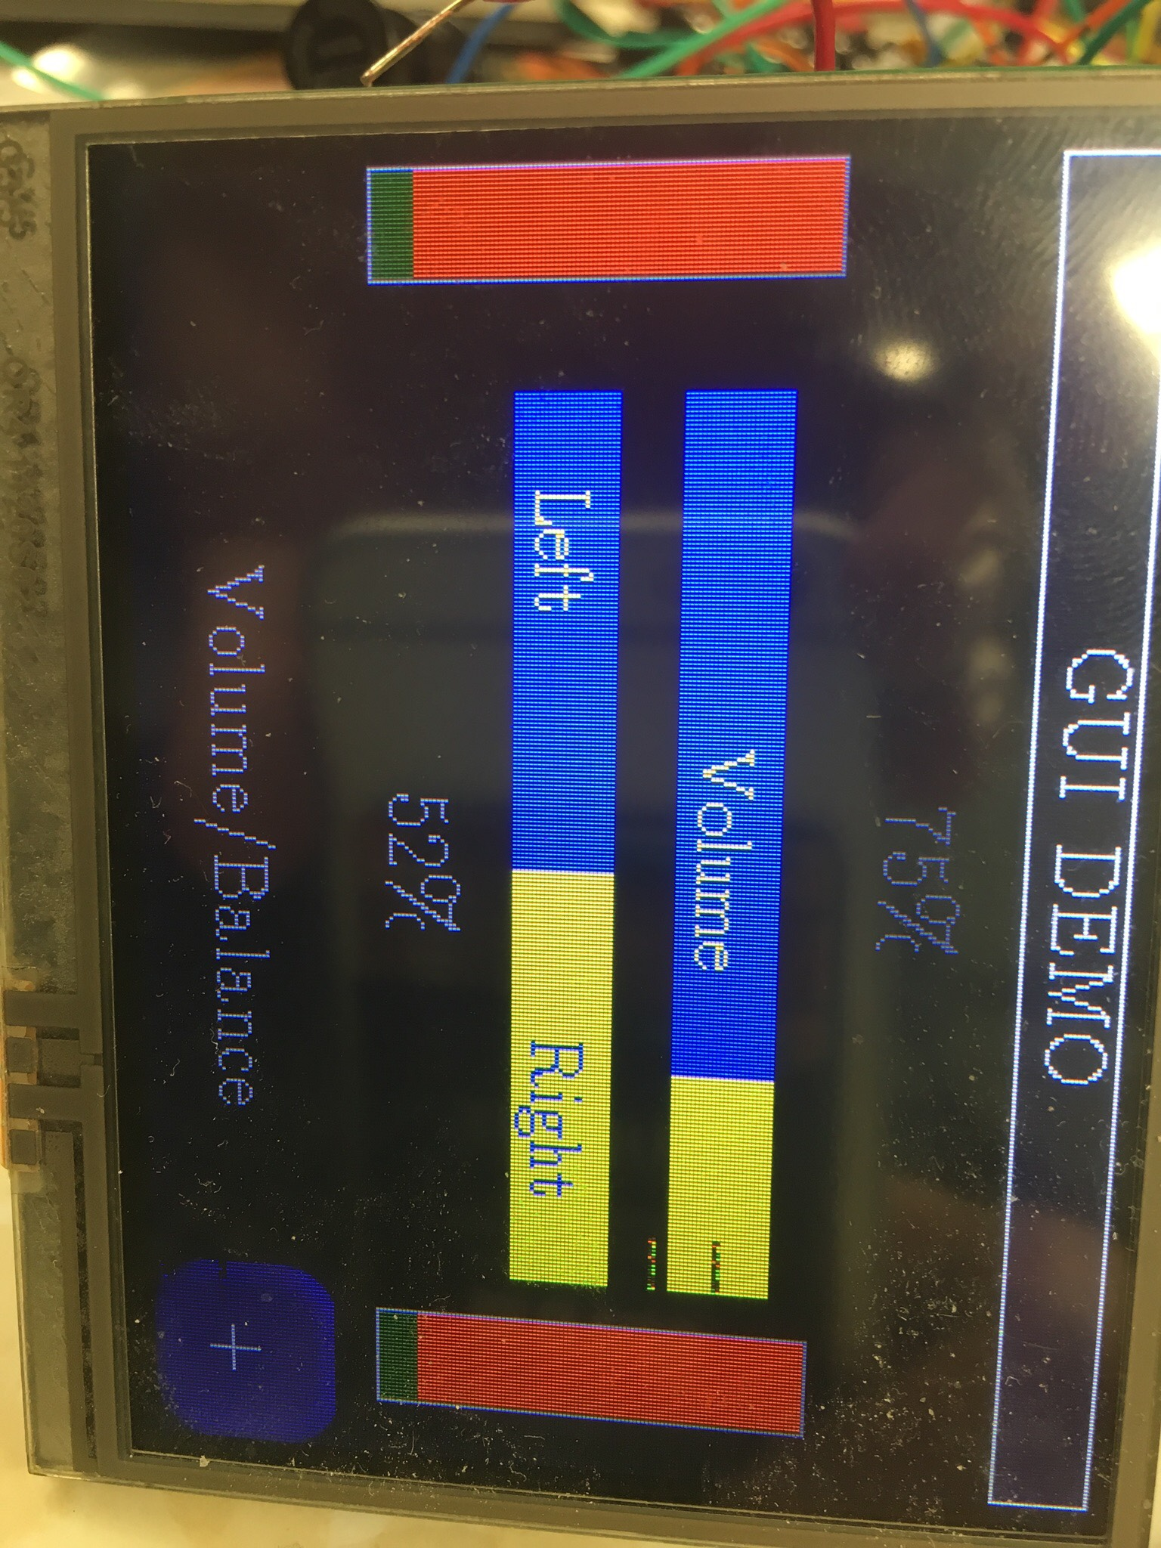

Figure 4.2.2: TIVA screen showing various volume levels(25%, 52% & 75%: left to right)

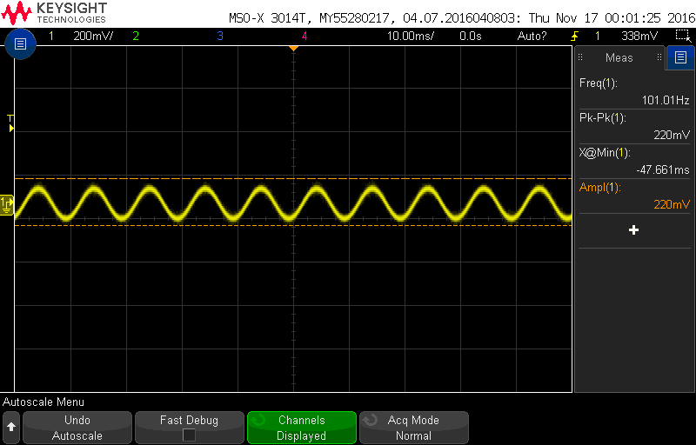

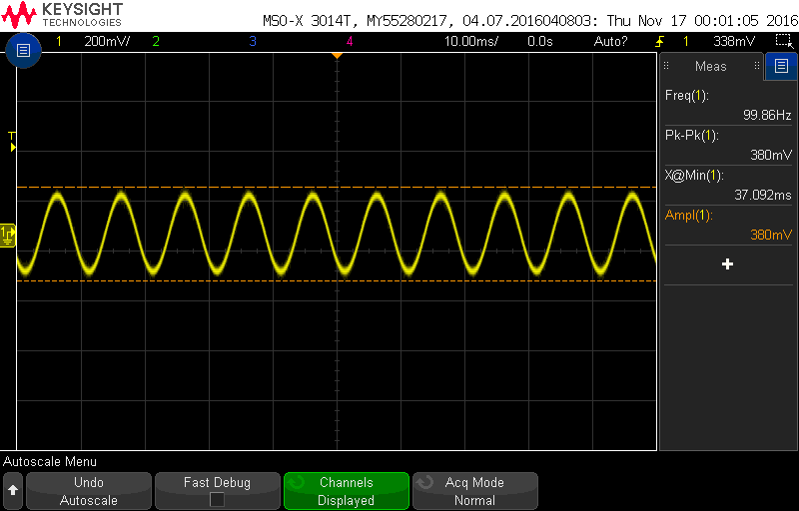

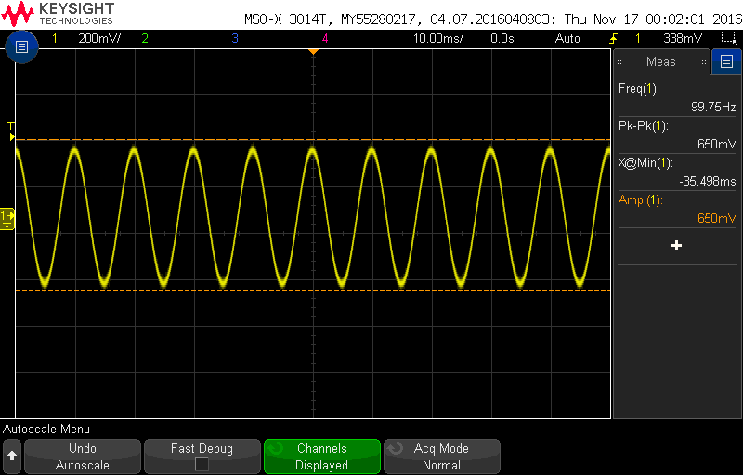

Figure 4.2.3: Oscilloscope results showing response to various volume levels

(25%, 52% & 75%: top to bottom)

The above plots show successful integration between the two sub-system as the increase in volume level on the TIVA screen results in increase in voltage levels depicted by the oscilloscope plots.

## 4.3 Power Amplifier with Amplifier Controls

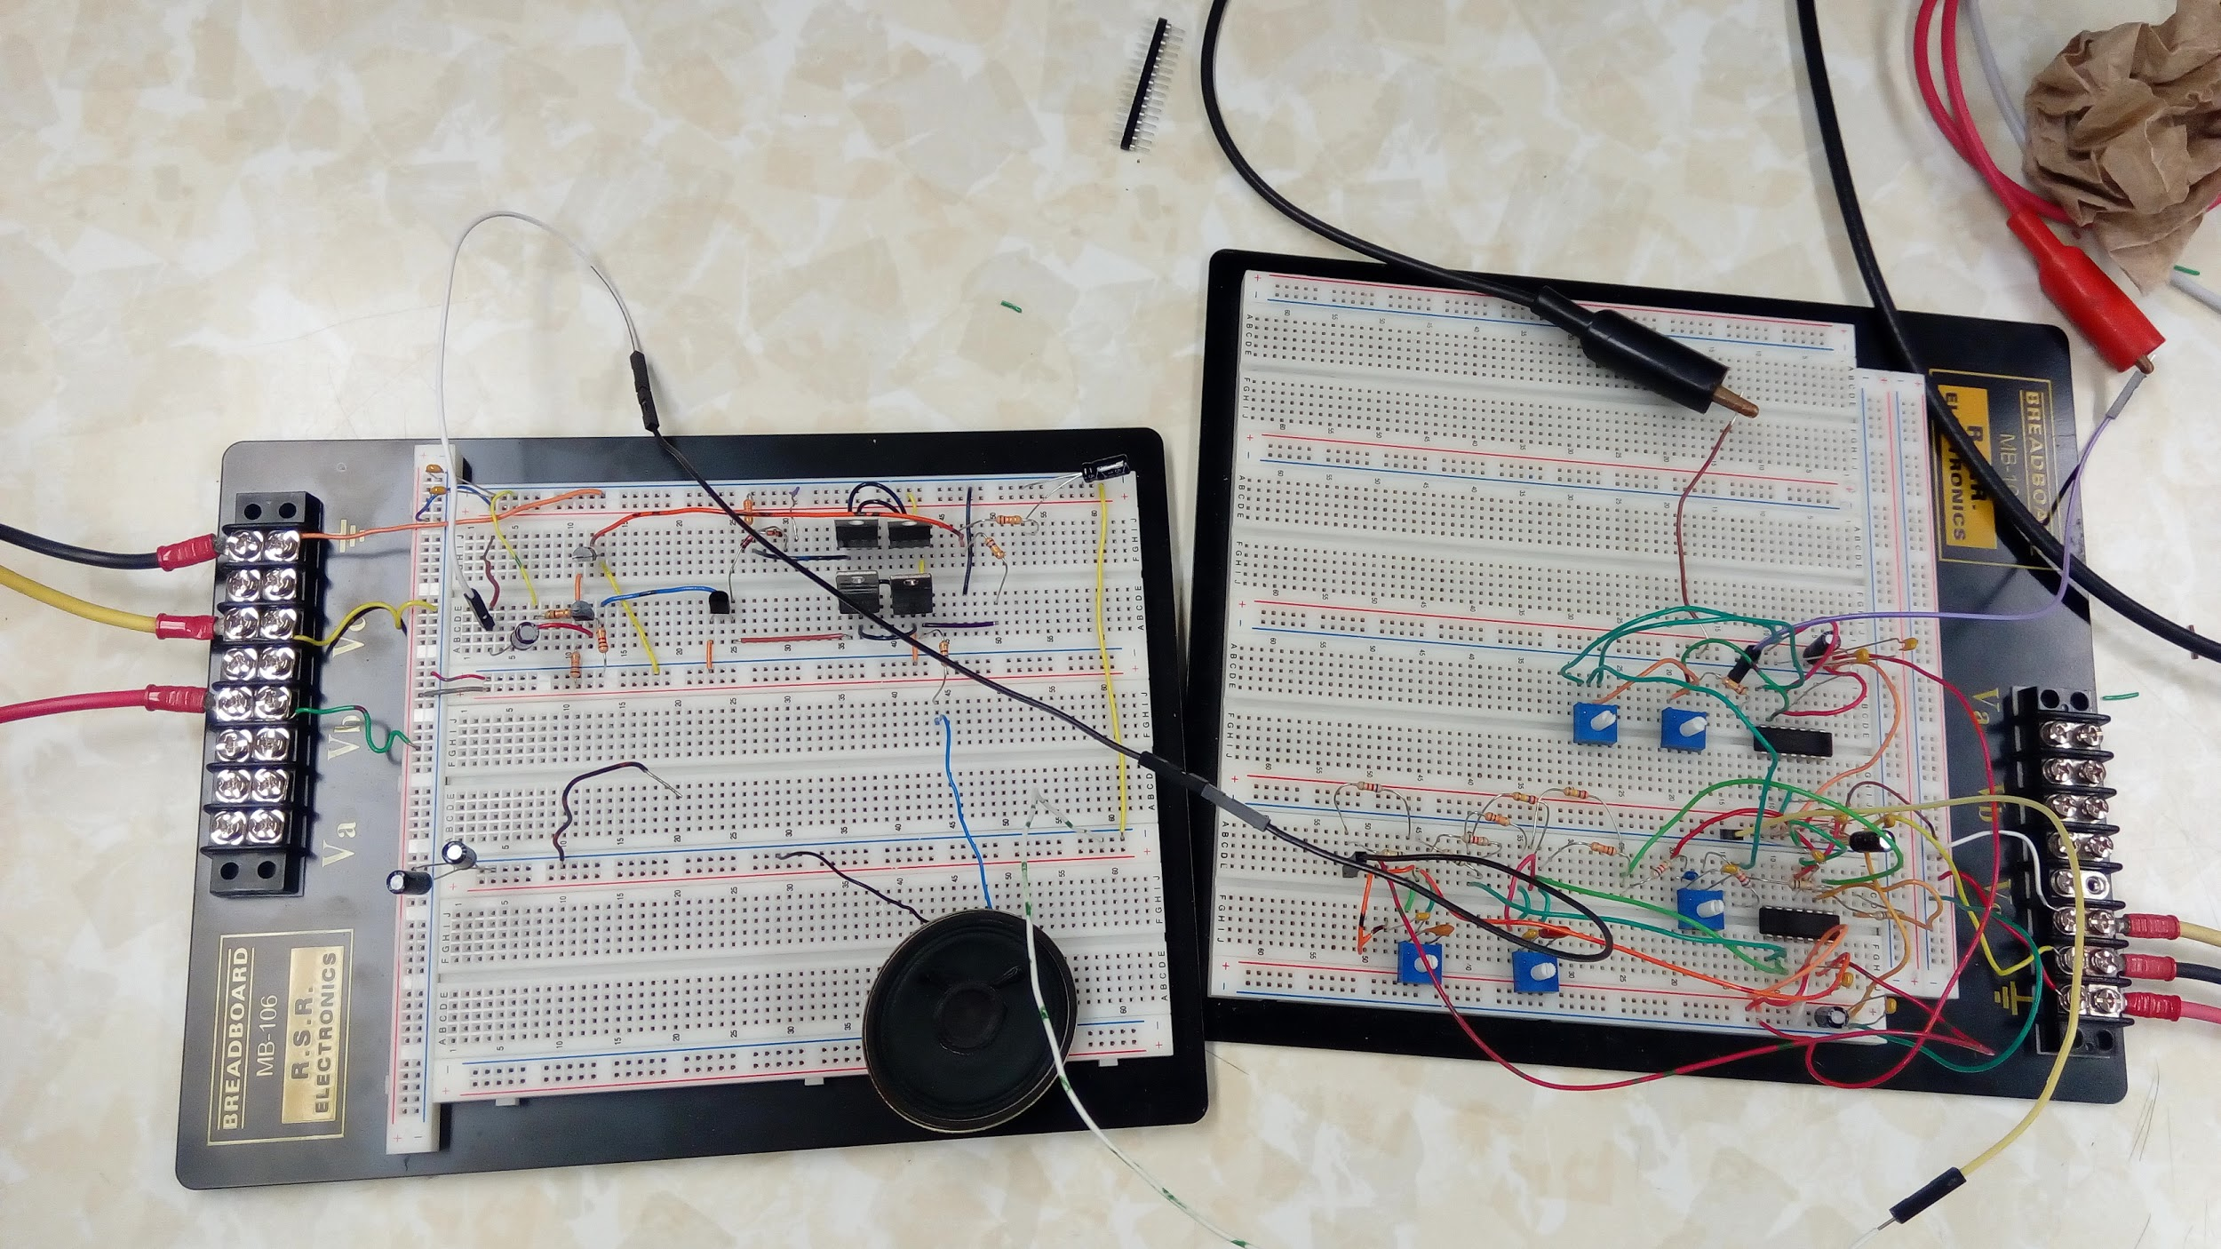

Figure 4.3.1: Integrated breadboard Circuits (Power Amplifier(left) and Amplifier Controls(right))

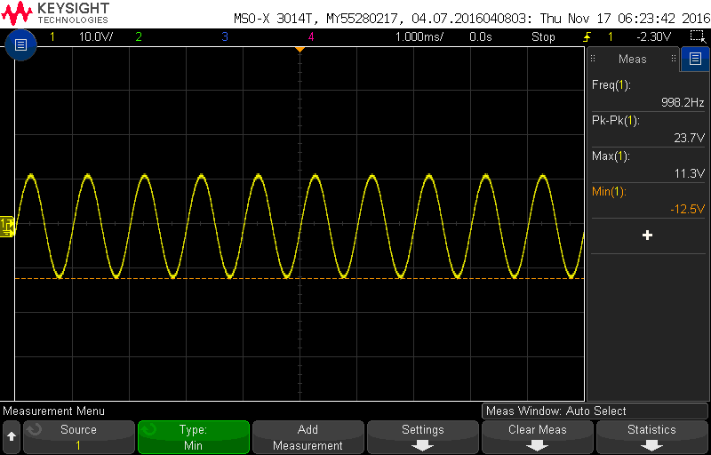

Figure 4.3.2: Voltage Amplification Plot

The above plot shows successful integration between the two sub-system as there is a good voltage gain as observed by the plot on the oscilloscope plot.

## 4.4 System Integration

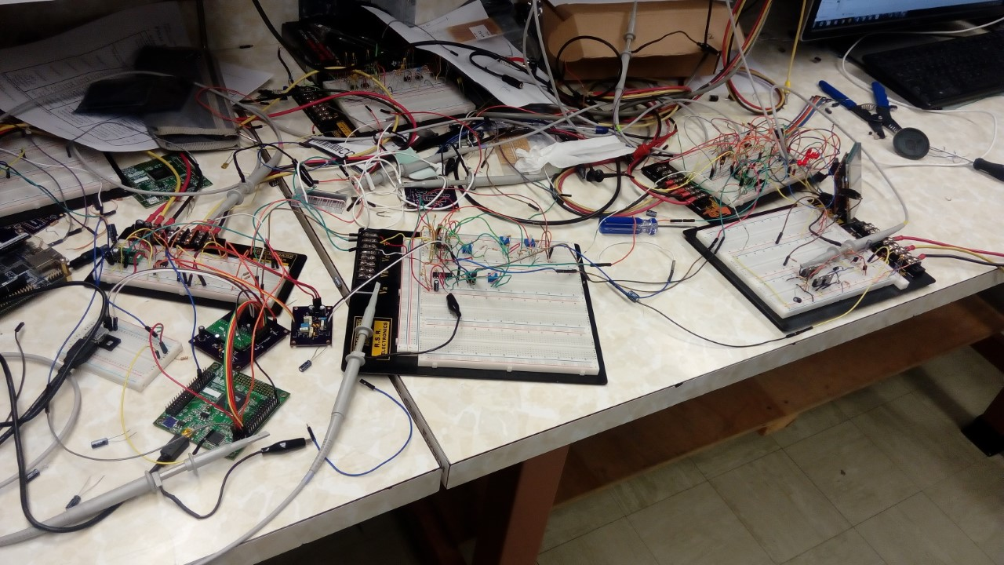

Figure 4.4.1: Integrated breadboard Circuits (D to A, Amplifier Controls,Power Amplifier, VU/GUI: right to left)

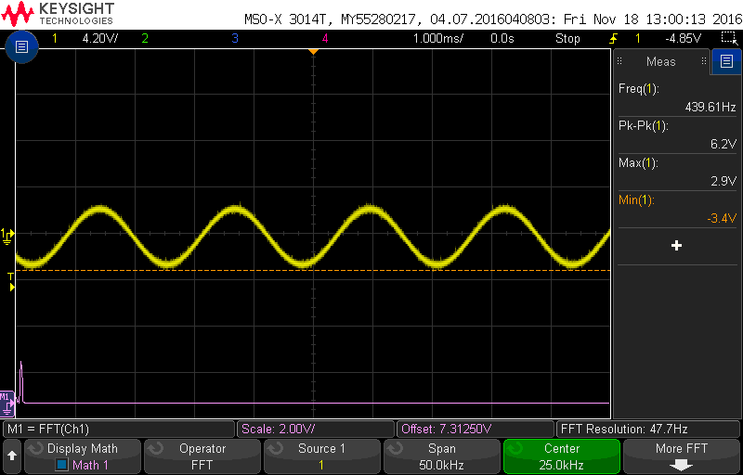

Figure 4.4.2: Voltage Amplification plot at 25% volume on TIVA

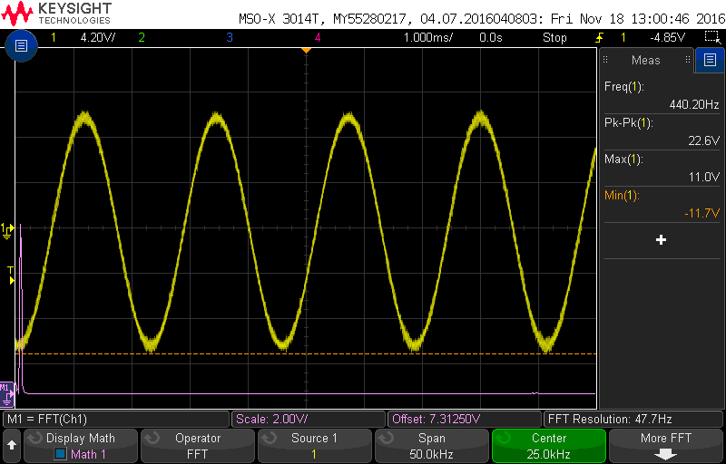

Figure 4.4.3: Voltage Amplification plot at 75% volume on TIVA

We were successfully able to connect our system together. We did have some noise in the circuit as seen from the FFT graph on the above plots.

# 5. Final Acceptance Test

* Be able to connect your system using a USB cable to a PC running windows. 
* Connect a set of headphones from the list provided.
* Play music on the PC and hear it in the headphones.
* Swap the headphones for any other provided on the list.
* Control the volume, balance, treble, midrange and bass using a touchscreen GUI.
* Observe the VU meter during playback
* Be provided with a calibration certificate showing compliance or deviation from the specifications.

The team is very close to the overall goal of making an assembled prototype of the Transparent USB Audio Headphone Amplifier. We integrated our system for testing purposes. The system (D to A) can be successfully connected to a PC using USB. The volume, balance, treble, bass and midrange levels can be controlled using the touchscreen provided. The VU meter can also be observed during the playback. The system was found to be working for various resistance values indicating it will support the list of headphones (with different impedance values) provided. Our system is able to meet most of the specifications provided by the customer. Individually we are working towards soldering and testing our PCBs. The order for the PCB for the VU/GUI has been placed. By final demo, we aim to complete our PCBs and resolve any leftover issues.

# 6. Schedule Of Deliverables

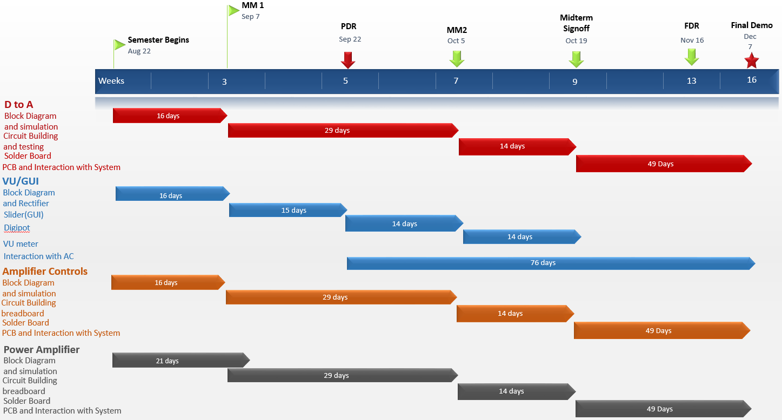

# 7. Known Costs

**D to A:**

CPLD ISPMACH 4256ZE price= $26.5 or FPGA=$99

Mylar Film Capacitor 1n\*6, 15n\*2, 2.2n\*2, 0.1n\*2=$0.3 \*12= $3.6

USB port \*1=$1.2

12 MHz Crystal Oscillator \*1=$3.2

OPA1612 \*6 price= $5\*6=$30

PCB (one channel) = $83

**Amplifier Controls:**

PCB (both channels) = $84.35

**Power Amplifier:**

PCB (both channels) = $26.45

Solder Board = $15.79

**VU GUI:**

MCP41HVX1 \*10 price = 1.37\*10 = $13.7

PCB (both channels) = $86.70

Approximately: $374.49 / unit

# Appendix A. Specification Sheets

